KANSAS Registered Teacher Apprenticeship

Sequence and Duration Guidance
Kansas leads the world in the success of each student.
22 May 2024

Introduction 2
Sample Plan 4
Overview 4
Categories/Constructs 4
Competencies/Components 5
Sample Apprenticeship Plan 6
1.1 Learner Development 8
1.2 Learner Differences 10
1.3 Learning Environment 12
2.1 Content Knowledge 14
2.2 Innovative Applications of Content Knowledge 16
3.1 Planning for Instruction 18
3.2 Assessment 20
3.3 Instructional Practices 22
4.1 Reflection and Continuous Growth 24
4.2 Collaboration and Leadership 26

Introduction
Kansas Registered Teacher Apprentices must demonstrate proficiency in 10 competencies, also known as components, before completing their four-year program. These competencies fall into the four overarching categories listed below known as constructs.
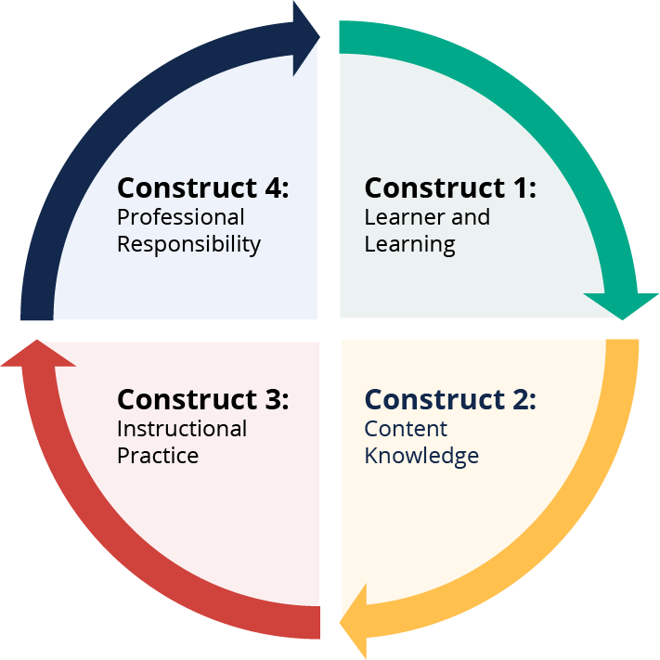
Construct 1. Learner and Learning
1.1 The teacher plans instruction based on learning and developmental levels of all students.
1.2 The teacher recognizes and fosters individual differences to establish a positive classroom culture.
1.3 The teacher establishes a classroom environment conducive to learning.
Construct 2. Content Knowledge
2.1 The teacher demonstrates a thorough knowledge of the content.
2.2 The teacher provides a variety of innovative applications of knowledge.

Construct 3. Instructional Practice
3.1 The teacher uses methods and techniques that are effective in meeting student needs.
3.2 The teacher uses varied assessments to measure learner progress.
3.3 The teacher delivers comprehensive instruction for students.
Construct4. Professional Responsibility
4.1 The teacher engages in reflection and continuous growth.
4.2 The teacher participates in collaboration and leadership opportunities.
There is no set requirement for the sequence and duration that competencies are introduced. However, the sample plans provided below include examples of what that could look like.
The Kansas Educator Evaluation Protocol (KEEP) guidance documents address each of the four constructs and 10 competencies through a model of continuous improvement. Apprentices will follow this model to begin building a continuous improvement mindset.
Each district will decide how and when to introduce the 10 competencies. The sample plan created by the Kansas State Department of Education (KSDE) illustrates how phasing in the competencies can be accomplished by introducing the four constructs pictured above sequentially beginning with Construct 1 then adding Constructs 2, 3, and 4, one at a time. Starting with Construct 1 provides apprentices the basics of developing classroom management skills that address the needs of all students (1.1), classroom culture (1.2), and classroom environment (1.3). Districts may choose to phase in first competencies with less complicated concepts, then introduce complex competencies as the apprentice gains experience, knowledge, and confidence. Examples are provided in the sample plan below.
 | Year 1: First Quarter | Year 1: Second Quarter | Year 1: Third Quarter | Year 1: Fourth Quarter | Years 2-4
Construct(s) | 1 | 1and 2 | 1, 2 and 3 | 1, 2, 3 and 4 | 1, 2, 3 and 4
The advantage of a four-year apprenticeship program is that districts do not have to overwhelm apprentices with the entirety of the KEEP rubric (or even the entirety of a single construct) immediately.

Sample Plan

Overview
The sample plan presented below illustrates how to introduce the four KEEP constructs sequentially, with one building upon another, as well as how to phase in competencies so that rigor is increased gradually for the apprentice.
Please note that:
- Neither method is mandatory. Districts determine how the constructs and competencies will be introduced.
- Districts should work closely with their partnering college/university to determine the cadence of coursework in order to best align on-the-job experiences.
- Apprentices will enter the program at all different levels and with different needs. Districts and colleges/universities will want to factor in these differences to create an experience that will be most relevant to each apprentice.

Categories/Constructs
The sample plan below introduces the four categories/constructs by starting with Construct 1, and then adding on Constructs 2, 3, and 4 over time. This allows the apprentice to build a strong foundation in the critical area of classroom management that will support the introduction of all other constructs.

Sample of Construct Introduction for First Year Apprentices:
 | Year 1: First Quarter | Year 1: Second Quarter | Year 1: Third Quarter | Year 1: Fourth Quarter | Years 2-4
Construct(s) | 1 | 1and 2 | 1, 2 and 3 | 1, 2, 3 and 4 | 1, 2, 3 and 4
This is only one of many options that could be utilized, and the unique needs of the apprentice should be considered. For example, for some apprentices, it may be more important to begin with a focus on Construct 4 (Professional Responsibility) and build from there.

Competencies/Components
When considering each competency, there is a wide range of development that each educator can demonstrate as their expertise grows. As an example, competency 1.1 states that “The teacher plans instruction based on learning and developmental levels of all students.” KSDE has KEEP guidance documents that explain competency 1.1 includes key indicators such as “planning instruction, aligning instruction with student learning needs, using a variety of approaches and resources, providing adaptation of instruction.” What each district will need to decide is where to start when introducing these skills to their apprentice(s), and how to build from there. As a reminder, these are examples only, and each district should determine what will work best for the unique needs of their apprentice(s). These unique needs can vary depending upon the setting, prior experience of the educator, and job type (example: a special education teaching apprentice and general education teaching apprentice may have different learning needs). It should be noted that the InTASC standards (which were used for guidance when developing the KEEP) helped guide the development of the examples below.

Apprentice Plan
Notes:
- To create your own copy of this plan that can be edited in Google Docs, press “File” followed by “Make A Copy.” Or, to create your own copy in Microsoft Word that can be edited, press “File,” followed by “Download,” followed by “Microsoft Word.”
- All red text on the following pages should be deleted and replaced by the mentor and/or building administrator.
- The plan below is subject to change and may be modified at any time by the mentor/administrator to better meet the needs of the apprentice.
- While the Competencies, Desired Demonstrations, Possible Evidence, and verbiage from the “Proficient” columns on the following pages are all taken directly from KEEP guidance, for the sake of clarity, the word “teacher” has been changed to “apprentice” when appropriate.
- It is important for apprentices, mentors, and administrators to understand that a ranking of “Beginning” does not indicate failure. “Beginning” should be the expected level in the early stages of an apprenticeship. These rubrics serve as a conversation guide and should aid apprentices and mentors in understanding how to move through the levels as the apprenticeship progresses.
- Whether to use this resource as guidance or as an official evaluation is at the discretion of the school district. For example, the district may use this resource to foster discussion between the apprentice and mentor, while still utilizing a standard evaluation tool from the school district for the apprentice’s official evaluation.

Sample Apprenticeship Plan
This form should be completed by mentor or administrator of the apprentice.
Apprentice: | Replace this text with the apprentice’s name.

Mentor: | Replace this text with the mentor’s name.

Administrator: | Replace this text with the administrator’s name (typically the building principal).

This year’s plan for categories/constructs:
Replace this text with the timeline for when categories/constructs will be worked on this year. As a reminder, the KEEP has four constructs: 1) Learner and Learning, 2) Content Knowledge, 3) Instructional Practice, and 4) Professional Responsibility. An example of how a plan for these constructs may appear is:
 | Year 1: First Quarter | Year 1: Second Quarter | Year 1: Third Quarter | Year 1: Fourth Quarter | Years 2-4
Construct(s) | 1 | 1and 2 | 1, 2 and 3 | 1, 2, 3 and 4 | 1, 2, 3 and 4

- First Quarter of School Year 1: Construct 1
- Second Quarter of School Year 1: Constructs 1 and 2
- Third Quarter of School Year 1: Constructs 1, 2 and 3
- Fourth Quarter of School Year 1: Constructs 1, 2, 3 and 4.
This is an example only, and the order/focus of the constructs is at the discretion of the apprentice’s mentor, with the final authority belonging to the building principal.
Review Meeting Dates:
Replace this text with the dates for when meetings will occur with the apprentice to discuss and document their present levels on the rubrics included in the following pages.
Please note that it is recommended that only constructs that are currently being worked on (as described in the plan for this year - see above) should be covered during this meeting. There is no required frequency for this meeting; meetings can occur monthly, quarterly, etc.
Review Meeting Agendas: Replace this text with the basic outline for the agenda at Review Meetings. Agendas can include specifics such as who will be present, whether the apprentice will self-reflect on the rubrics below prior to the meeting, which competencies will be covered, how the information for present levels will be shared with the apprentice, etc.
Signatures: After all red text above has been deleted and this plan has been viewed by the principal, mentor, and apprentice, the date and signature fields below should be completed.
Apprentice Signature: Date:
Mentor Signature: Date:
Administrator Signature: Date:

1.1 Learner Development
The apprentice plans instruction based on learning and developmental levels of all students.
Desired Demonstration, Possible Evidence and Levels of Progression (Basic, Moderate, Complex) for 1.1.
Desired Demonstration | Beginning | Developing | Proficient | Possible evidence
Planning and alignment of instruction. | The apprentice assists veteran educators in the development of lesson and unit plans with specific attention paid to sections related to differentiation and unique needs of students. | The apprentice independently attempts the development of lesson plans and the delivery of instruction that demonstrates differentiation to address the unique needs of learners. | Lesson and unit plans reflect consistent alignment with the students’ learning needs and illustrate how the apprentice takes into consideration the developmental levels of all students. | - Apprentice lesson plans
Using a variety of teaching approaches and resources. | The apprentice assists veteran educators in the development of lesson plans with specific attention paid to sections related to varied teaching styles. | The apprentice independently attempts the development of lesson plans and the delivery of instruction that demonstrates a variety of teaching approaches and resources. | Lesson plans and student work consistently reflect a variety of approaches to help students learn. Observations or artifacts of classroom activities over a period of time provide evidence of the variety. | - Apprentice lesson and/or unit plans.  - Student work samples.  - Learning style inventories.  - Observations (by peers or evaluators).
Adapting instruction to meet student needs. | The apprentice observes and assists veteran educators as they adapt instruction to meet student needs. Discussions occur following lessons about future instructional adaptations. Reflective notes are kept regarding future practice applications. | The apprentice attempts a variety of practices to reflect upon personal instruction. Possible examples include reflective journaling, recording/watching a lesson, collecting/reviewing student feedback, adjusting lessons based upon student work samples, etc. | The apprentice consistently reflects on instruction both during and after and provides both written and oral evidence of this. | - Apprentice reflection.  - Samples of student work.  - Conference notes with colleagues.

Notes, Goals, Resources/Supports, and Updates for 1.1.
Notes on what competency 1.1 looks like in the apprentice’s classroom.
Enter notes on the apprentice’s current performance for competency 1.1 here.
What goal(s) and targeted completion date(s) do we have for competency 1.1?
Enter a goal (or goals) for the apprentice related to competency 1.1. A projected completion date for the goal(s) will be included.
Resources/Supports
Enter notes regarding what resources and assistance will be provided to the apprentice to help them achieve the goal(s) outlined above by the established date.
Updates
Enter an update on whether the goal (or goals) was accomplished by the established date (this information can also be used to establish goals for the next cycle).

1.2 Learner Differences
The apprentice recognizes and fosters individual differences to establish a positive classroom culture.
Desired Demonstration, Possible Evidence, and Levels of Progression (Basic, Moderate, Complex) for 1.2.
Desired Demonstration | Beginning | Developing | Proficient | Possible evidence
Knowledge of all students. | The apprentice reviews examples of student surveys, student writing, parent surveys, and student data. Observations and notes of how these tools are utilized to drive student interactions are gathered and documented. | The apprentice has some demonstrated examples of interacting with students in a respectful manner, encouraging and respecting them as they share their thoughts and experiences. | The apprentice consistently interacts with students in a respectful manner, encouraging and respecting them as they share their thoughts and experiences. | - Student surveys.  - Student writing.  - Parent surveys.  - Student attendance data.
Using knowledge of students to create a culture of respect among all students. | The apprentice reviews samples of student writing and discussion. They collect rules from a variety of classrooms and interview veteran educators as to the rationale for said rules. | Disciplinary data is reviewed, and possibilities of how to utilize this data (to support positive student behavior) are generated. Veteran educator(s) review and revise these possibilities with the apprentice, and then finalized work is implemented. | Student writing and discussion provides consistent evidence of contributions of personal experiences to the topics being studied during class. | - Student reflections/ contributions of personal experience.  - Classroom rules.  - Behavior and/or office referrals.

Notes, Goals, Resources/Supports, and Updates for 1.2.
Notes on what competency 1.2 looks like in the apprentice’s classroom.
Enter notes on the apprentice’s current performance for competency 1.2 here.
What goal(s) and targeted completion date(s) do we have for competency 1.2?
Enter a goal (or goals) for the apprentice related to competency 1.2. A projected completion date for the goal(s) will be included.
Resources/Supports
Enter notes regarding what resources and assistance will be provided to the apprentice to help them achieve the goal(s) outlined above by the established date.
Updates
Enter an update on whether the goal (or goals) was accomplished by the established date (this information can also be used to establish goals for the next cycle).

1.3 Learning Environment
The apprentice establishes a classroom environment conducive to learning.
Desired Demonstration, Possible Evidence, and Levels of Progression (Basic, Moderate, Complex) for 1.3.
Desired Demonstration | Beginning | Developing | Proficient | Possible evidence
The apprentice is seen consistently involving students in various classroom activities, giving the student opportunities to give direction to their own learning. | The apprentice interviews, observes, and documents how veteran educators involve students in various classroom activities, and how they provide students with opportunities to give direction to their own learning. | The apprentice creates a plan for how they will involve students in various classroom activities/give students direction to their own learning. The apprentice will also make initial attempts to put this plan into action. | The apprentice is seen consistently involving students in various classroom activities, giving the student opportunities to give direction to their own learning. | - Classroom rules developed collaboratively.  - Student surveys.  - Student developed rubrics.
Student work provides consistent evidence that students are being academically challenged at their appropriate level. | Through collaboration with veteran educators, the apprentice is able to assist in developing lesson plans that will provide academic challenge of the appropriate level to students. | The apprentice is often able to demonstrate evidence that students are being academically challenged at their appropriate level. | Student work provides consistent evidence that students are being academically challenged at their appropriate level. | - Lesson plans.  - Classroom expectations.  - Observations (by peers or evaluators).  - Student work samples.  - Feedback to students.

Notes, Goals, Resources/Supports, and Updates for 1.3.
Notes on what competency 1.3 looks like in the apprentice’s classroom.
Enter notes on the apprentice’s current performance for competency 1.3 here.
What goal(s) and targeted completion date(s) do we have for competency 1.3?
Enter a goal (or goals) for the apprentice related to competency 1.3. A projected completion date for the goal(s) will be included.
Resources/Supports
Enter notes regarding what resources and assistance will be provided to the apprentice to help them achieve the goal(s) outlined above by the established date.
Updates
Enter an update on whether the goal (or goals) was accomplished by the established date (this information can also be used to establish goals for the next cycle).

2.1 Content Knowledge
The apprentice demonstrates a thorough knowledge of content.
Desired Demonstration, Possible Evidence, and Levels of Progression (Basic, Moderate, Complex) for 2.1.
Desired Demonstration | Beginning | Developing | Proficient | Possible evidence
Knowledge of content by encouraging use of multiple representations, explanations, and a wide variety of experiences. | Apprentice reviews the lesson plans of veteran educators and observes them providing instruction. The apprentice documents examples of how state standards are presented to students in a variety of modalities. | Through lesson plans and instruction, the apprentice is often able to demonstrate an alignment of targeted state standards to instruction, through diverse experiences provided to students during lessons. | Evidence observed shows the apprentice consistently provides a variety of instructional strategies that provide students a range of experiences to learn content. | - Lesson plans aligned to content standards.  - Curriculum committee work documentation.  - Observations of strategies used to deliver content (by peers or evaluators).
Build student understanding. | The apprentice observes veteran teachers during instruction and assists with grading student work from the same lessons by way of rubrics. | The apprentice creates lesson plans, assignments, and rubrics, and then utilizes them during instruction. The apprentice grades work via said rubrics and receives feedback from their mentor regarding overall student understanding. | Student work, judged according to a rubric, consistently shows understanding of key content area topics. | - Student work samples.  - Student feedback and reflection pieces.  - Apprentice developed assessments and rubrics.  - Student involvement in content contests.

Notes, Goals, Resources/Supports, and Updates for 2.1
Notes on what competency 2.1 looks like in the apprentice’s classroom.
Enter notes on the apprentice’s current performance for competency 2.1 here.
What goal(s) and targeted completion date(s) do we have for competency 2.1?
Enter a goal (or goals) for the apprentice related to competency 2.1. A projected completion date for the goal(s) will be included.
Resources/Supports
Enter notes regarding what resources and assistance will be provided to the apprentice to help them achieve the goal(s) outlined above by the established date.
Updates
Enter an update on whether the goal (or goals) was accomplished by the established date (this information can also be used to establish goals for the next cycle).

2.2 Innovative Applications of Content Knowledge
Apprentice provides a variety of innovative applications of knowledge.
Desired Demonstration, Possible Evidence, and Levels of Progression (Basic, Moderate, Complex) for 2.2.
Desired Demonstration | Beginning | Developing | Proficient | Possible evidence
Use of problem solving, critical thinking skills, and technology. | The apprentice assists veteran educators with lesson plans with a focus on critical thinking skills. Lessons that utilize these plans are observed by the apprentice. The apprentice documents planning and instructional techniques for critical thinking. | With mentor guidance, the apprentice develops lesson plans that promote critical thinking skills. The apprentice teaches said lessons and is receptive to feedback on how student critical thinking can consistently be achieved in future lessons. | Evidence consistently shows effective use of critical thinking skills in developing content-based assignments; questions promote evaluation and synthesis rather than recall. | - Problem-solving based assignments with student responses.  - Student created videos.
Explores and delivers content through real-world application of knowledge. | The apprentice reviews the state standards for their grade level (or subject area) and creates examples of how each could be taught in a method that clearly demonstrates the real world application for each standard. | With mentor guidance, the apprentice develops lesson plans that promote real world application. The apprentice teaches said lessons and is receptive to feedback on how student critical thinking can consistently be achieved in future lessons. | A collection of student work over a period of time consistently shows practical application of content. | - Portfolio of materials associated with real-world application of topics of study.  - Feedback from community member regarding a project tied to a real-world activity.
Collaborates to provide cross curricular learning opportunities. | The apprentice assists veteran educators with lesson plans with a focus on cross curricular learning opportunities. Lessons that utilize these plans are observed by the apprentice. The apprentice documents planning and instructional techniques for cross curricular learning opportunities. | With mentor guidance, the apprentice develops lesson plans that provide cross curricular learning opportunities. The apprentice teaches said lessons and is receptive to feedback on how cross curricular learning opportunities can consistently be achieved in future lessons. | Evidence from lesson plans shows students making use of a variety of content areas within one activity. | - Co-curricular performances tied to the subject area.  - Unit plans from collaborative planning.

Notes, Goals, Resources/Supports, and Updates for 2.2
Notes on what competency 2.2 looks like in the apprentice’s classroom.
Enter notes on the apprentice’s current performance for competency 2.2 here.
What goal(s) and targeted completion date(s) do we have for competency 2.2?
Enter a goal (or goals) for the apprentice related to competency 2.2. A projected completion date for the goal(s) will be included.
Resources/Supports
Enter notes regarding what resources and assistance will be provided to the apprentice to help them achieve the goal(s) outlined above by the established date.
Updates
Enter an update on whether the goal (or goals) was accomplished by the established date (this information can also be used to establish goals for the next cycle).

3.1 Planning for Instruction
The apprentice uses methods and techniques that are effective in meeting student needs.
Desired Demonstration, Possible Evidence, and Levels of Progression (Basic, Moderate, Complex) for 3.1.
Desired Demonstration | Beginning | Developing | Proficient | Possible evidence
Plans rigorous activities. | The apprentice assists veteran educators with lesson plans with a focus on challenging/appropriate student activities. Lessons that utilize these plans are observed by the apprentice. The apprentice documents planning and instructional techniques that provide students with challenging and appropriate activities. | With mentor guidance, the apprentice develops lesson plans that provide students with challenging and appropriate activities. The apprentice teaches said lessons and is receptive to feedback on how students can consistently receive challenging and appropriate activities in future lessons. | Evidence from student work consistently shows that lessons are planned using challenging and appropriate activities. | - Formative and summative assessments (by peers and evaluators).  - Student work samples showing the rigor of the assignments.  - Apprentice and student reflections.
Uses objectives that align with standards. | The apprentice documents and is able to demonstrate knowledge of district, state, and national standards for their grade level and/or subject area(s). | The apprentice has documentation that compares current performance of their students to district, state, and national standards. A plan has been developed for how to address any student data that is below desired thresholds. | Assessment data consistently shows students meeting district, state, and national standards. | - Lesson plans noting relevant standards.  - Assessment data.
Meets needs of all students. | The apprentice has a portfolio specific to each of their students which includes relevant data and student work samples. | The apprentice has a portfolio specific to each of their students which includes relevant data, student work samples, and a plan for how to meet the unique needs of each student. | Evidence from portfolios collected over a period of time reflects student understanding of content appropriate for their individual needs. | - Student need inventory.  - Individual assessment data including portfolios.

Notes, Goals, Resources/Supports, and Updates for 3.1
Notes on what competency 3.1 looks like in the apprentice’s classroom.
Enter notes on the apprentice’s current performance for competency 3.1 here.
What goal(s) and targeted completion date(s) do we have for competency 3.1?
Enter a goal (or goals) for the apprentice related to competency 3.1. A projected completion date for the goal(s) will be included.
Resources/Supports
Enter notes regarding what resources and assistance will be provided to the apprentice to help them achieve the goal(s) outlined above by the established date.
Updates
Enter an update on whether the goal (or goals) was accomplished by the established date (this information can also be used to establish goals for the next cycle).

3.2 Assessment
The apprentice uses varied assessments to measure learner progress.
Desired Demonstration, Possible Evidence, and Levels of Progression (Basic, Moderate, Complex) for 3.2.
Desired Demonstration | Beginning | Developing | Proficient | Possible evidence
Provides opportunities for students to demonstrate learning. | The apprentice assists veteran educators in developing lesson plans which match appropriate assessment techniques with learning goals and observes the accompanying lessons. | With mentor guidance, the apprentice develops lesson plans which match appropriate assessment techniques with learning goals, uses the lesson plans to provide instruction, and receives/utilizes feedback from the mentor regarding how to improve this practice in the future. | Evidence consistently shows that students have a variety of ways to demonstrate their learning: oral presentations, portfolios. | - Scored rubrics from performance assessments.  - Assessment samples (formative and summative).  - Portfolios.  - Student presentations.
Uses assessment data to inform instruction. | The apprentice reviews local and state assessment data for the students in their class(es) and documents both individual and group information regarding strengths and weaknesses. | With mentor guidance, the apprentice uses local and state assessment data to develop lesson plans that address student needs. | Apprentice consistently provides rationales for chosen activities based on student assessment results. | - Apprentice reflection.  - Lesson plans linking activities to assessment results.
Provides feedback to promote student responsibility. | The apprentice reviews student feedback that is shared by veteran educators. Conferencing between veteran educators and students is observed. | The apprentice assists the mentor with grading papers and providing specific, qualitative and quantitative feedback to students. The apprentice leads conferences with students, with assistance and guidance from the mentor. | Written evidence from apprentice/student conference consistently shows student identification of next steps in the learning. | - Written feedback on student work.  - Observations (by peers or evaluators).  - Apprentice/student conferences.

Notes, Goals, Resources/Supports, and Updates for 3.2
Notes on what competency 3.2 looks like in the apprentice’s classroom.
Enter notes on the apprentice’s current performance for competency 3.2 here.
What goal(s) and targeted completion date(s) do we have for competency 3.2?
Enter a goal (or goals) for the apprentice related to competency 3.2. A projected completion date for the goal(s) will be included.
Resources/Supports
Enter notes regarding what resources and assistance will be provided to the apprentice to help them achieve the goal(s) outlined above by the established date.
Updates
Enter an update on whether the goal (or goals) was accomplished by the established date (this information can also be used to establish goals for the next cycle).

3.3 Instructional Practices
The apprentice delivers comprehensive instruction for students.
Desired Demonstration, Possible Evidence, and Levels of Progression (Basic, Moderate, Complex) for 3.3.
Desired Demonstration | Beginning | Developing | Proficient | Possible evidence
Uses a variety of strategies to engage and challenge students in a variety of learning situations. | The apprentice reviews lesson plans of veteran educators and observes their instruction. The apprentice creates a documented list of strategies for both student engagement, and academic challenge. Strengths and considerations for each strategy are included. | The apprentice drafts lesson plans, and with mentor assistance, the plans are refined to increase levels of student engagement and academic challenge. A variety of instructional techniques are utilized to meet this need. | Evidence from lesson plans consistently shows use of strategies to engage students in worthwhile content learning activities. | - Professional growth log.  - Lesson plans.  - Observations.
Incorporates strategies for differentiation and scaffolding for all students. | The apprentice reviews lesson plans of veteran educators and observes their instruction. Based on this work, the apprentice creates a documented list of strategies for scaffolding/differentiation. Strengths and considerations for each strategy are included. | The apprentice drafts lesson plans, and with mentor assistance, the plans are refined to better address scaffolding and differentiation needs. A variety of strategies are utilized to meet this need. | Apprentice consistently develops assignments that provide students with a variety of options and submission schedules. | - Apprentice reflection.  - Lesson plans showing how strategies were used for scaffolding/ differentiation.
Engages students in higher order thinking. | Based upon personal research and observations/interviews with veteran educators, the apprentice creates a documented list of activities associated with each level of Bloom’s Taxonomy. | The apprentice drafts lesson plans, and with mentor assistance, the plans are refined to better address higher order thinking skills and problem-solving activities. A variety of strategies are utilized to meet this need. | Apprentice consistently provides students with problem solving activities related to the classroom content. | - Student work samples that reflect use of higher-level thinking skills.

Notes, Goals, Resources/Supports, and Updates for 3.3
Notes on what competency 3.3 looks like in the apprentice’s classroom.
Enter notes on the apprentice’s current performance for competency 3.3 here.
What goal(s) and targeted completion date(s) do we have for competency 3.3?
Enter a goal (or goals) for the apprentice related to competency 3.3. A projected completion date for the goal(s) will be included.
Resources/Supports
Enter notes regarding what resources and assistance will be provided to the apprentice to help them achieve the goal(s) outlined above by the established date.
Updates
Enter an update on whether the goal (or goals) was accomplished by the established date (this information can also be used to establish goals for the next cycle).

4.1 Reflection and Continuous Growth
The apprentice engages in reflection and continuous growth.
Desired Demonstration, Possible Evidence, and Levels of Progression (Basic, Moderate, Complex) for 4.1.
Desired Demonstration | Beginning | Developing | Proficient | Possible evidence
Engages in ongoing, purposeful professional learning connected to student learning. | The apprentice creates a professional learning log, with space for: 1) notes; 2) applications for the classroom; and 3) evaluations of each experience. A section of potential professional development opportunities is compiled for future consideration. | The apprentice has participated in some professional learning opportunities outside of required university coursework. These activities have been documented in the apprentice’s professional learning log. | Apprentice consistently seeks professional learning experiences (workshops, courses, and self-study) and applies the learning to classroom activities. | - Professional development log noting connections to classroom application of learning.  - Written evaluation of a professional learning experience.  - Professional portfolio.
Reflects on practice and actively seeks opportunities for improvement. | The apprentice makes initial attempts at creating lesson plans. Once drafted, the lesson plans are reviewed by the apprentice’s mentor, and revision opportunities are shared. The apprentice will then create revised drafts, and revisions will continue until finalized copies are achieved. | The apprentice uses mentor-approved lesson plans to teach lessons and records themself providing instruction to students. The apprentice and mentor will review/discuss these recordings, including areas of strength and opportunities for growth. | Apprentice consistently welcomes feedback from peers in the development of lesson plans and the implementation of instruction and activities. | - Lesson plans with reflections on effectiveness of lesson and ideas for future improvements.  - Video recording of a lesson with feedback from a peer or evaluator.
Analyzing and reflecting on student data to impact student growth. | The apprentice learns how to access, acquire and document current collections of data that are available for students within their class(es). | The apprentice makes observations about strengths and weaknesses for each student within their class(es) based upon a variety of data sources. These observations are documented and provided to the mentor for feedback and advice. | Apprentice consistently collects data from a variety of sources and determines what students have and have not learned in order to address student learning needs. | - Formative and summative assessments.  - Data collection device for use over an extended period of time to see student growth.

Notes, Goals, Resources/Supports, and Updates for 4.1
Notes on what competency 4.1 looks like in the apprentice’s classroom.
Enter notes on the apprentice’s current performance for competency 4.1 here.
What goal(s) and targeted completion date(s) do we have for competency 4.1?
Enter a goal (or goals) for the apprentice related to competency 4.1. A projected completion date for the goal(s) will be included.
Resources/Supports
Enter notes regarding what resources and assistance will be provided to the apprentice to help them achieve the goal(s) outlined above by the established date.
Updates
Enter an update on whether the goal (or goals) was accomplished by the established date (this information can also be used to establish goals for the next cycle).

4.2 Collaboration and Leadership
The apprentice participates in collaboration and leadership opportunities.
Desired Demonstration, Possible Evidence, and Levels of Progression (Basic, Moderate, Complex) for 4.2.
Desired Demonstration | Beginning | Developing | Proficient | Possible evidence
Collaborated with multiple stakeholders in school and professional activities. | The apprentice documents what routine professional activities occur for teachers, and seeks invitations to attend, observe, and participate as appropriate. Possible examples include IEPs, PLC groups, General Education Intervention meetings, etc. Documentation of these opportunities and requests to attend are kept. | The apprentice begins attending professional activities and debriefs with the mentor after each. Conversations with the mentor focus on best-practices for meaningful engagement and participation in these professional activities. These debriefs are documented by the apprentice. | Evidence shows the apprentice’s consistent communication with a mentor to discuss a variety of learning strategies. | - Minutes of meetings: IEP, PLC, Student Improvement Team meetings.  - Notes from meetings with mentor.  - Contact logs.
Uses a variety of methods of communication. | The apprentice observes and learns from the mentor on appropriate email usage, classroom newsletters, parent phone calls, etc. Techniques for each are documented in a reflective journal. | With assistance from their mentor, the apprentice engages in communication with coworkers and parents via email, phone, newsletters, etc. Notes on interactions are logged in a reflective journal. | The apprentice consistently uses a reflective journal and shares ideas from that with colleagues in a team meeting. | - Copies of communication: emails, letters, newsletters.  - Log of phone calls.
Demonstrates leadership skills used to support and improve student learning. | The apprentice reviews a variety of agendas from meetings throughout the school and observes the accompanying meetings when possible. Veteran educators are interviewed to learn about best-practices when developing agendas and facilitating meetings. | With the assistance of veteran educators, the apprentice attempts to develop meeting agendas and receives feedback on improvements. Feedback is utilized to enhance agendas, and the apprentice co-facilitates meetings with the support of veteran educators. | Apprentice consistently initiates meetings with a variety of groups such as caregivers, peers and teachers of the same content to improve student learning. | - Agendas generated by the apprentice in a team leadership role.  - Portfolio of leadership activities.

Notes, Goals, Resources/Supports, and Updates for 4.2
Notes on what competency 4.2 looks like in the apprentice’s classroom.
Enter notes on the apprentice’s current performance for competency 4.2 here.
What goal(s) and targeted completion date(s) do we have for competency 4.2?
Enter a goal (or goals) for the apprentice related to competency 4.2. A projected completion date for the goal(s) will be included.
Resources/Supports
Enter notes regarding what resources and assistance will be provided to the apprentice to help them achieve the goal(s) outlined above by the established date.
Updates
Enter an update on whether the goal (or goals) was accomplished by the established date (this information can also be used to establish goals for the next cycle).

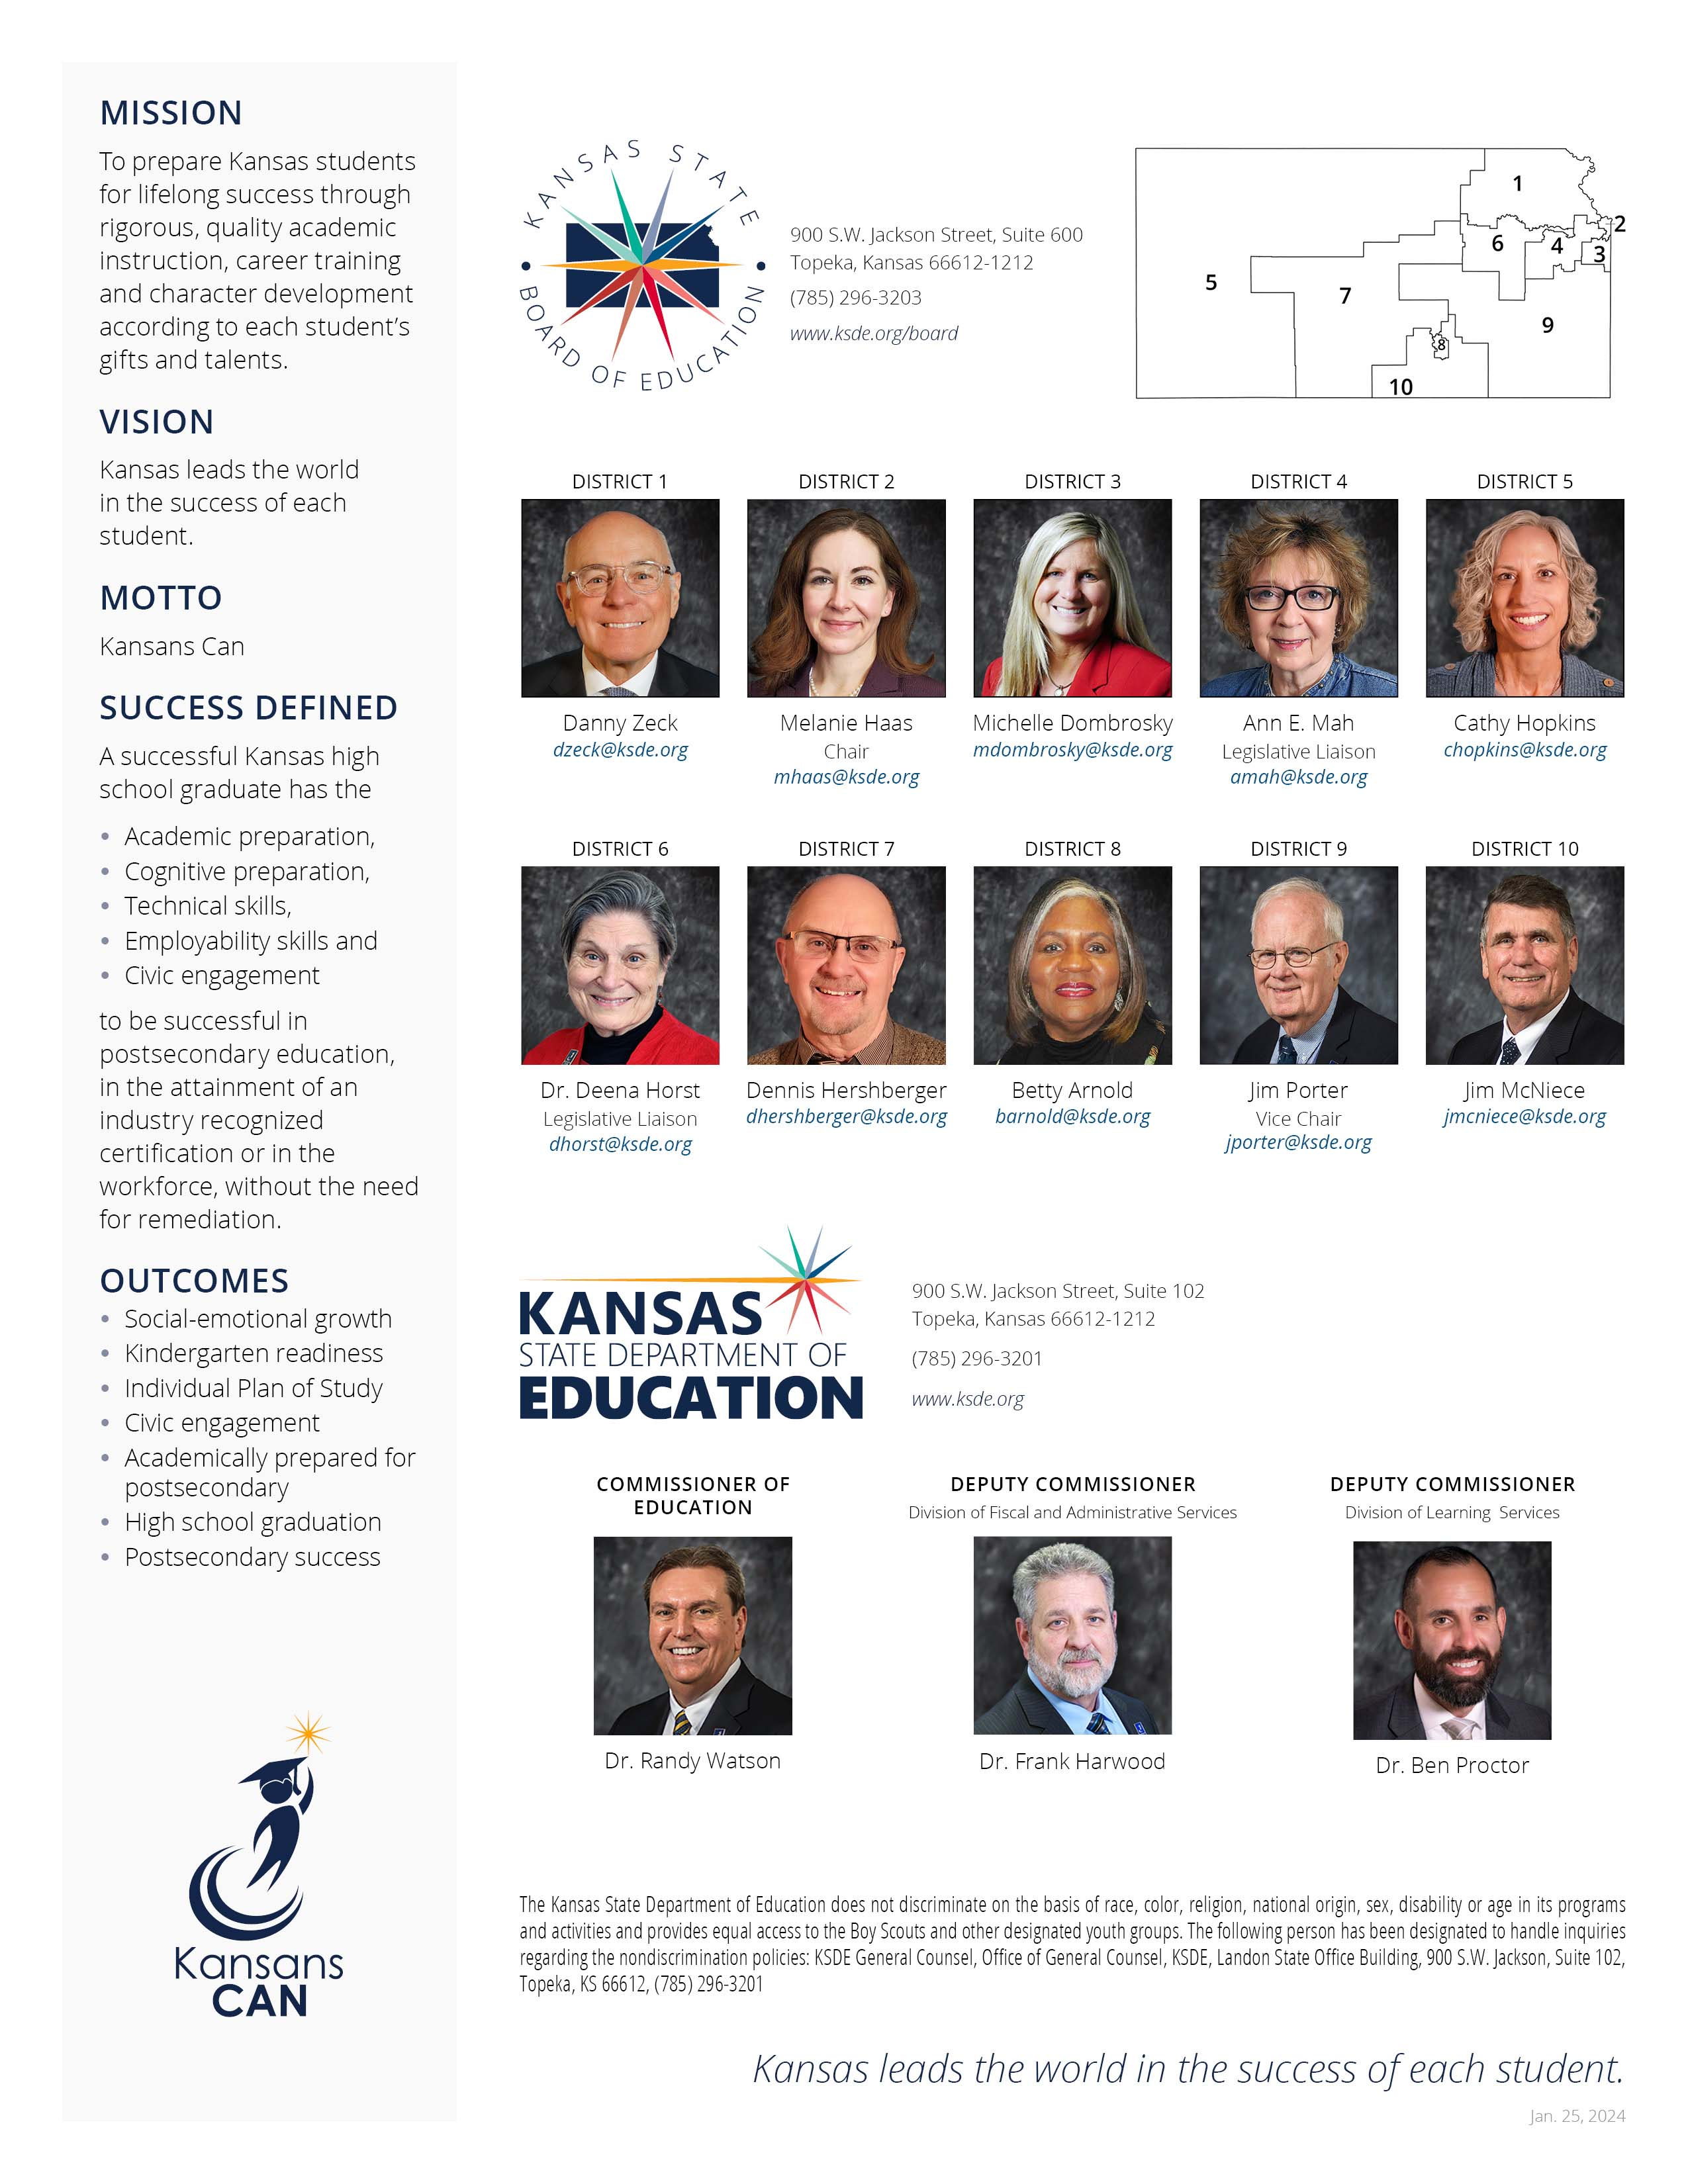

For more information, contact:  Registered Teacher Apprenticeship  Teacher Licensure  (785) 296-2288  apprentice@ksde.org |  | Kansas State Department of Education  900 S.W. Jackson Street, Suite 102  Topeka, Kansas 66612-1212  https://www.ksde.org

https://www.ksde.org/Portals/0/TLA/Educator Eval/KEEP Teacher Instructional Practice Protocol.pdf?ver=2017-12-13-151222-820
https://ccsso.org/resource-library/intasc-model-core-teaching-standards-and-learning-progressions-teachers-10

