

**SPEDPro**

**Special Education Data Project**

**User’s Guide**

<https://www.ksde.org/Default.aspx?tabid=519>

*Kansas leads the world in the success of each student.*

Month Year



**An Equal Employment/Educational Opportunity Agency**

The Kansas State Department of Education does not discriminate on the basis of race, color, national origin, sex, disability or age in its programs and activities and provides equal access to the Boy Scouts and other designated youth groups. The following person has been designated to handle inquiries regarding the nondiscrimination policies: KSDE General Counsel, Office of General Counsel, KSDE, Landon State Office Building, 900 S.W. Jackson, Suite 102, Topeka, KS 66612, (785) 296-3201

Table of Contents

|  |  |  |
| --- | --- | --- |
| Part I: Introduction | | 3 |
| Part II: About this Manual | | 3 |
| Part III: Important Terms | | 4 |
| Part IV: Registering for Access to SPEDPro and the Special Education MIS Collection System | | 5 |
| Part V: Logging into SPEDPro | | 8 |
| Part VI: Welcome Page | | 11 |
| Part VII: Getting Started – Begin Year set up | | 12 |
|  | Calendars List Page | 12 |
|  | Settings List Page | 15 |
|  | Building Information Page | 18 |
|  | Personnel List Page | 20 |
| Part VIII: Data Entry | | 23 |
|  | Student Search | 24 |
|  | Student Profile List | 25 |
|  | IEP List | 32 |
|  | Service Lines | 36 |
|  | Gifted students exiting IDEA / Part B services | 43 |
| Part IX - Verification Process - Overview | | 45 |
|  | Trouble Shooting – Fixing specific verifications | 49 |
|  | Using Reports for Verification and Data Quality Checks | 51 |
| Part X: Importing Files | | 52 |
| Part XI: Non-public Equivalency Contracts (NPE Contracts) | | 55 |
| Part XII: Catastrophic Aid | | 60 |
| Part XIII: Reports | | 66 |
| Part XIV: Discipline Data | | 71 |
| Part XV: Security and Personally Identifiable Information (PII) | | 72 |
| Part XV: Help Resources | | 73 |
| General Navigation Tips | | 74 |

Related Documents

|  |  |  |
| --- | --- | --- |
| **Date** | **Document Title** | **Location** |
| FY 2025 | MIS Data Dictionary | www.ksde.org / MIS and student data |
| All Year | NPE Contract Forms | www.ksde.org / Special education / Fiscal resources |
| All Year | Catastrophic Aid Application | www.ksde.org / Special education / Fiscal resources |
|  |  |  |

Revision History

|  |  |  |
| --- | --- | --- |
| **Date** | **Reason for Changes** | **Version** |
| 08/01/2015 | New Application Release. | 1.0 |
| 03/22/2016 | Catastrophic Aid and NPE guidance updated | 1.1 |
| 10/06/2016 | Updates to Discipline data and Reports | 2.0 |
| 06/12/2017 | Data Entry - Students moving within Coop / Interlocal Member districts | 3.0 |
| 07/31/2017 | Section XIV - Using SPEDPro to verify student level data | 3.1 |
| 09/01/2017 | Added Using Report to Verify Data section | 4.0 |
| 04/01/2018 | Part XVI; Security and PII | 4.0 |
| 06/05/2018 | Service Minutes clarified | 4.0 |
| 06/20/2018 | Provider Profile redesign | 4.0 |
| 06/25/2018 | Non-Accredited Private School Organization | 4.0 |
| 03/30/2019 | Building Information Guidance | 5.0 |
| 03/30/2019 | Neighborhood School for Private / Parochial students | 5.0 |
| 03/30/2019 | Modifying Service End Dates | 5.0 |
| 11/25/2019 | Edit Student Profile Guidance | 5.0 |
| 02/20/2020 | Promote Provider Function | 6.0 |
| 07/01/2022 | Update Provider Role title | 8.0 |
| 07/01/2022 | Discipline Report title revision | 8.0 |
| 07/01/2024 | New section – Trouble shooting specific verifications | 10.0 |

# Part I: Introduction

The SPEDPro application is designed to collect data on Kansas special education students submitted by Local educational agencies, to KSDE to meet state and federal data reporting requirements. SPEDPro also incorporates data from other KSDE applications for calculations of state and federal data categories. SPEDPro also utilizes a data verification process and a report tool for generating current year data quality reports, projected and final state and federal reports. SPEDPro also stores history of these reports.

# Part II: About this Manual

This User’s Guide begins with an overview of KSDE Authentication and logging into SPEDPro. You will then be introduced to the system itself.

Also included in this guide are some notes and tips that highlight important topics.

***NOTE:***The “Notes” box will mention items that require special attention.

***TIP Boxes:***“Tip” boxes in the User Guide will contain recommendations and/or “shortcuts” for the user to employ as they work in the SPEDPro application.

**Part III: Important Terms**

Below is a glossary of terms that are associated with SPEDPro.

|  |  |
| --- | --- |
| **Term** | **Meaning** |
| Actions Menu | Menu on student record to view, edit, delete or to access student data pages |
| Directory /  Directory Updates | The KSDE web application that contains a database of all building data. SPEDPro displays the building schedules and program types on the Building Information page |
| KIDS Data | Student records in SPEDPro are populated with data from KIDS Collection by the corresponding student ID and organization. Student name, date of birth, gender, ELL status and responsible school are sourced from the KIDS Collection records. |
| Organization | The Local Educational Agency (LEA) associated to students, providers, buildings, calendars, etc. in SPEDPro |
| Student Profile | The student’ demographic page in SPEDPro |
| User type | Also known as Access level or the permissions an individual would have when accessing the application, such as read only, edit capabilities etc. |

Note: The SPEDPro User’s Guide is intended to provide guidance on the data entry process and the functionality of the SPEDPro application. The SPEDPro User’s Guide does not present or establish any data reporting rules or requirements. The KSDE Special Education Individual student data Report Preparation Instructions and Data Dictionary is the sole source for the reporting standards, rules, and procedures for Special Education data reporting.

**NOTE:** The SPEDPro User Guide only purpose is to present functionality guidance for navigation, report creation, student search, data entry, and data analysis within the application. The User Guide does not provide business rules or reporting standards. Examples presented in the User Guide only illustrate how a task is completed. Examples / screen shots do not establish reporting requirements.

See the Report Preparation Instructions and Data Dictionary for business rules and reporting requirements.

**Part IV: Registering for Access to SPEDPro and the Special Education MIS Collection System**

New User Registration

Individuals who do not have access to KSDE web applications need to register to establish an account. Individuals who currently have access to KSDE applications will need to request access to SPEDPro. To register for a new user account, use the following web address: <https://online.ksde.org/authentication/login.aspx>.

At this website, click on the **Register** button, as shown below:

***NOTE:***You may want to skip this section if you have already registered for access to SPEDPro, under the same organization.

SPED Coop staff members, who need access to all districts in the coop, would create an account under their 700-range organization ID to gain access to all member districts collectively. Interlocals staff register under their 600-range organization ID to gain access to all districts collectively.

If the user has an account under an individual district, a new account is needed associating the user to the Coop or Interlocal level. This will require a new registration under the 600 / 700 ID. A new User name is needed to associate the user to this new level of access.

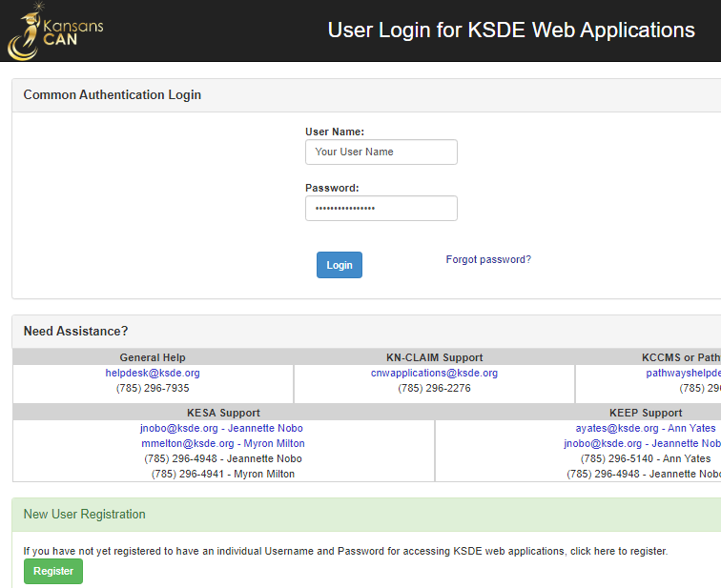

On the Registration page, enter the required information as indicated by the red asterisk. Under the Organization section, select the organization name and **all** buildings.

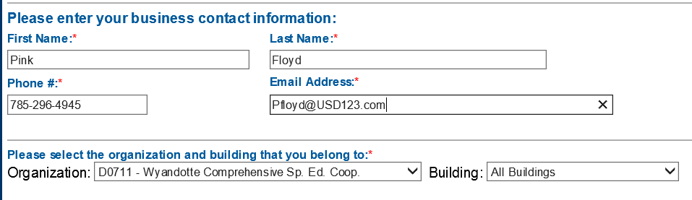

Mark the application “SPEDPro” and select the application access level from the list.



Access Levels

MIS Clerk - “District Update” - Full rights to enter, edit, delete, export, run reports.

SPED Director - Full rights to enter, edit, delete, export, run reports

SPED Teachers - Read only,

Other SPED Staff - Read only

***TIP:***Do not use spaces when defining your login ID. When creating your password keep in mind the password requirements shown on the screen. You will need to remember the Login ID, password, security question/answer, and birth date that you entered. KSDE does not store this information for you.

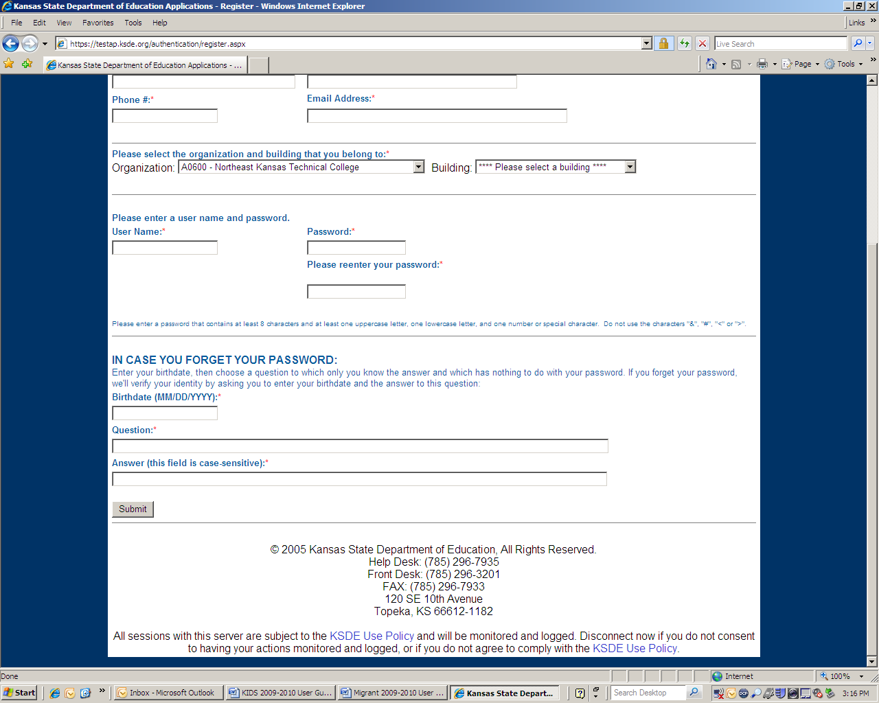Fill in the birth date, security question and answer. When you have completed all required information on the registration form, click the **Submit** button at the bottom of the screen.

If all data on the registration form is valid, you will see a message reading “Thank You for Registering”. The registration request will be routed for approval. Once approved, you will receive an email confirming your access request is approved, and your username and password are ready for use.

Existing Users Requesting SPEDPro Access

Individuals that currently have access to KSDE web applications will need to request access to SPEDPro. Use the **Manage My Account** option to add SPEDPro to the list of approved applications.

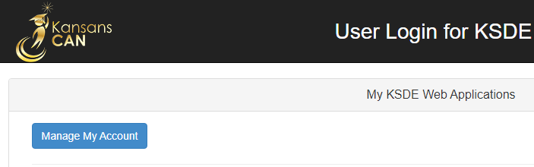

Follow these steps to add SPEDPro to your list of available KSDE web application:

1. Login on the KSDE Web Applications page
2. Click the **Manage My Account** link (shown above)
3. Check the box in front of SPEDPro.
4. Select your access level.
5. Click **Submit**

For other application such as the Special Education MIS Collection System, follow the same steps.

Your request will be routed for approval. Please alert the KSDE MIS Data Manager to the names of new staff applying for access permissions. Once approved, you will receive an email confirming your access request is approved.

***TIP:***If you forget your KSDE web applications password, click on the link that says “Forgot Your Password?” on the Authentication screen. You will be prompted to supply the answer to a security question (the question entered when you originally registered), type in your birth date, and enter a new password. If your security question answer and birthday match what you originally entered when you registered for KSDE web application access, then your new password will be activated. Remember; KSDE does not store your password, so you are responsible for managing and remembering it.

# Part V: Logging into SPEDPro

SPEDPRO, like the other KSDE web applications, is available on the KSDE Authentication page. To access SPEDPRO, enter your KSDE username and password to the KSDE Web Applications page.

<https://apps.ksde.org/authentication/login.aspx> .

Next Acceptance of the KSDE Legal Notice is required.

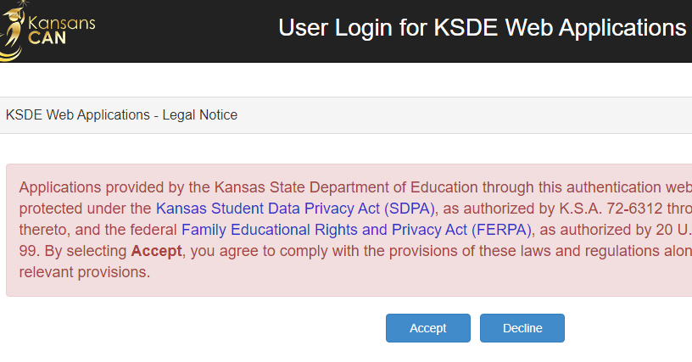Locate SPEDPro in the list of approved KSDE applications (example list shown below) and click on the application to open it.

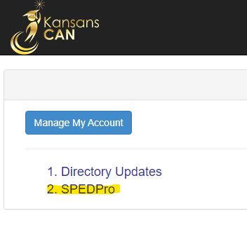

***NOTE:***Some of the applications may be grayed out. This means that they are either not active applications, or that you have not yet been approved for access to those applications.

The Select Organization is the first page displayed after opening the application.

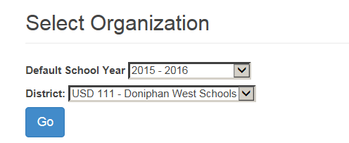

Go button – Sets the application to the selected organization and default school year.

Selecting the Default school year and District sets these defaults on each page of the application. Clicking “Go” sets these defaults. Other school years and districts may be selected on different pages, but the application will return to the default values after the page refreshes or different values are selected on the Select Organization page.

Coop and Interlocal users - Set the District default to the Coop (700) or Interlocal (600) number to manage data for all member districts collectively.

**First Alert -** Do not use the back button on your web browser when navigating in SPEDPro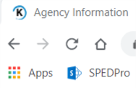

Use the (left side) Navigation Pane and Links to navigate to and from pages within SPEDPro

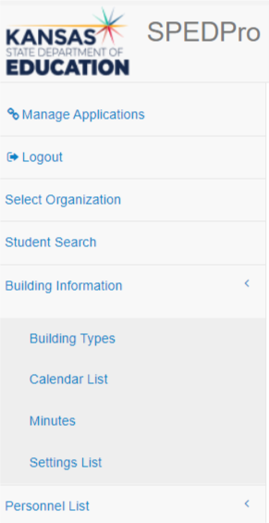

# Part VI: Welcome Page

Welcome page confirms the user’s level of access and school year.

The main section is where you will find the welcome screen. It will contain any special messages and will change as updates occur.

* The left section provides the user with a list of available menu items. These links take the user to different pages with SPEDPro to complete different tasks.



# Part VII: Getting Started – Begin Year set up.

Prior to entering students, the following steps must be completed first. – Timeline: July – August completion.

Create calendars for the school year.

Mark and submit current year setting codes for building and programs.

Enter current year providers in the Personnel List

## Calendars List Page

New Calendar

To create a new Calendar, click on **New** in the upper right corner of the Calendar List screen.

Select the current school year and District.

Start with a universal default district calendar, apply to all grades for D0 & S0 organizations.

Create a separate calendar for buildings and programs that do not follow the default district calendar.

Schools in X0 and Z0 organizations require a building level calendar only.

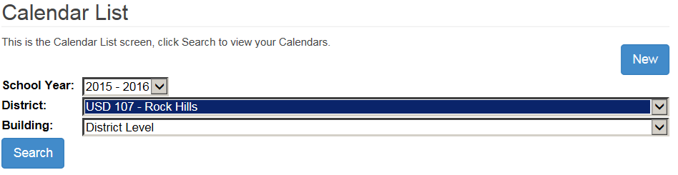

Follow these steps in sequence.

1. On the calendar list page, click the new button.
2. On the calendar form page,
3. Required fields as indicated by the Red * asterisk.
   1. School year - Select the current school year.
   2. District – Select the USD
   3. Building – Select the District level for the default calendar.
      1. Select individual building if the program does not follow the default calendar.
   4. Calendar type – Select all grades for the default calendar.
      1. Select All Kindergarten / All preschool for grades not following the default calendar.
   5. Select the Enter the first and last day of school.
4. Click the date for all day’s school is not in session, students are NOT in attendance.
   1. The days not in session will grayed when selected. Weekends are also in grey. The remaining “white” days will apply to the total days of service on the service lines.
5. Save the calendar.

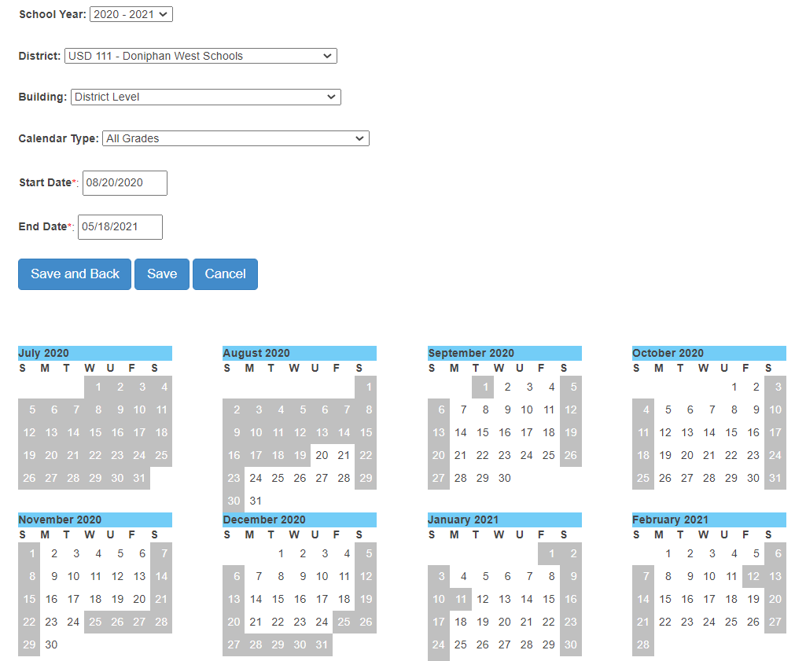

**NOTE:**Calendars need to align with the building / program sessions reported in the Directory. A 4 day a week preschool session in the Directory will need a corresponding 4 day a week calendar to assure the calculation of total days of service is accurate.

Private / Parochial School Calendars

Permissions to create Private / Parochial school calendars is based on the USD that bounds the Private / parochial school. This indicator is marked by building in the Directory Updates application.



The process for creating Private / Parochial school calendars is the same.  
Create a building specific level calendar for all Private / Parochial schools.

Step 1 - Click the “New” button.

Step 2 – Select the school year.  
Step 3 – Change the district to the Z0 or X0 Private / Parochial organization   
Step 4 – Select the individual building   
Step 5 – Select applicable grade levels  
Step 6 – Enter first and last day of school  
Step 7 – Mark the school days not in session  
Step 8 - Save

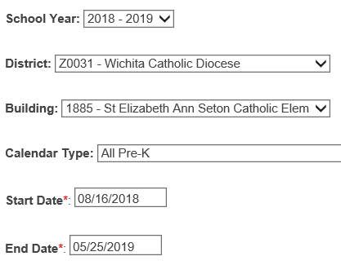

**Calendar Search:**

In the Calendar List screen, the top portion of the screen displays the calendar list for all buildings you have access to view. If you need to narrow the results, use the drop-down arrows to display a specific School Year, District, or Building. Click on **Search**. Once you find the building, you have several options. The actions you have available are to Edit, Copy, Delete and create New.

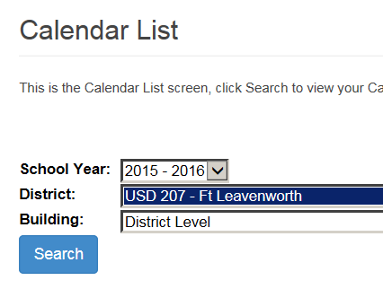

Edit Calendar

When you select Edit Calendar from the drop-down menu to the left of the building, the original calendar now becomes editable. Changes can be made and saved.

**NOTE:**Changing a calendar after current year data has been submitted may result in numerous verifications on existing service lines. If in-session school days are removed from an original calendar, this may result if fewer school days available within the range of service dates. Resulting total days of service on existing service lines may be more than the original days, triggering the verification because school days were removed.

Contact KSDE if a calendar edit is being considered after the original submission of student records.

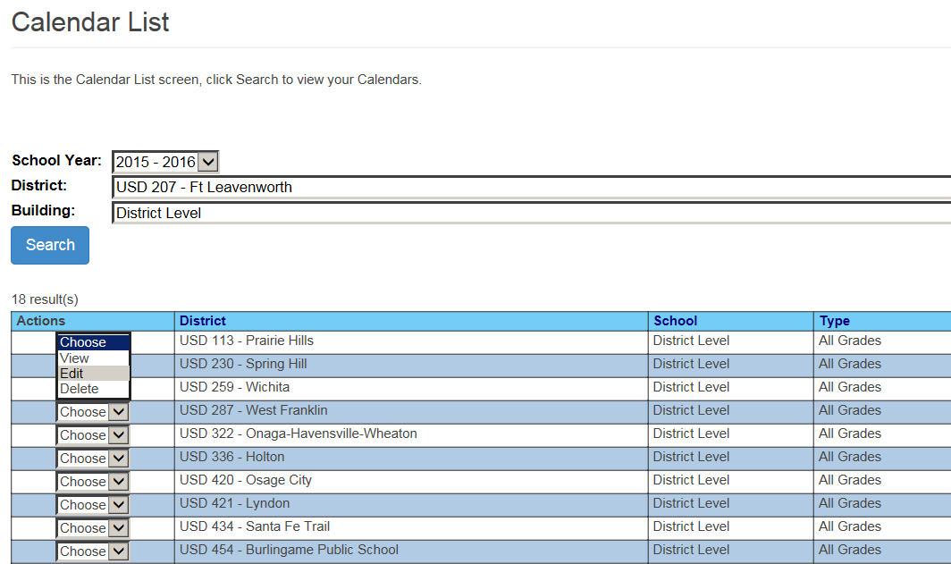.

To make changes to the Calendar, click on an individual day to either select that day or deselect that day, whichever is the case. Once you have made all the necessary changes, click on **Save**. You will be brought back to the Calendar List screen.

Delete Calendar

To delete a Calendar, click on Delete from the drop-down arrow to the left of the building that has the calendar that needs to be deleted. A box that requires you to verify that this calendar should be deleted is displayed. Click on OK to delete or Cancel to return to the Calendar List screen without taking action.

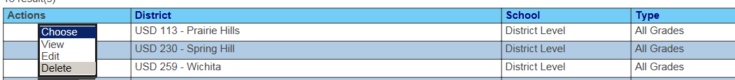

## Settings List Page

Each school building and program has a defined set of setting codes that represent the type of educational programs offered in that building by classroom. The Special Education report preparation and Data Dictionary defines each setting and the related setting code. Prior to the initial submission of student level data for the school year, a discovery process is completed to determine what specific program types are offered in each building in the current school year. This information is shared with the local board clerk who completes the KSDE Directory updates. Preschool program types are listed individually in the Directory and are visible on the SPEDPro Building information page. Enter the SPEDPro settings codes to equal / align with the program types listed in the Directory. Incorrect Directory updates can be fixed by the local board clerk.

**New Settings**

After the Discovery process is complete, begin the process of enters the set of setting codes for each school building and program.

1. From the navigation pane, click Settings list to open the Settings List page.
2. Click the New button to open a settings list form for each building.
   1. The building settings now have a status of “**In Progress**”. Meaning “being worked on” but not yet complete.

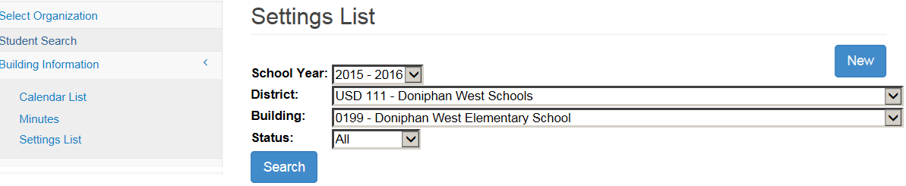

1. Select the current school year
2. Select the District
3. Select the Building (allow the page to refresh), the form is now ready for entry
4. Mark the check box to the right of the setting description.
   1. Note: Extracurricular (T) and Indirect (X) settings are defaulted / pre-marked
5. When all settings have been marked, four options are available on the building form
   1. Save. This keeps the settings list at In Progress status to add or remove additional settings.
   2. Save and Submit. This confirms the setting list is complete and moves the status to “**Submitted”**.
   3. Delete and Cancel. Returns the user to the settings list page with no actions taken.

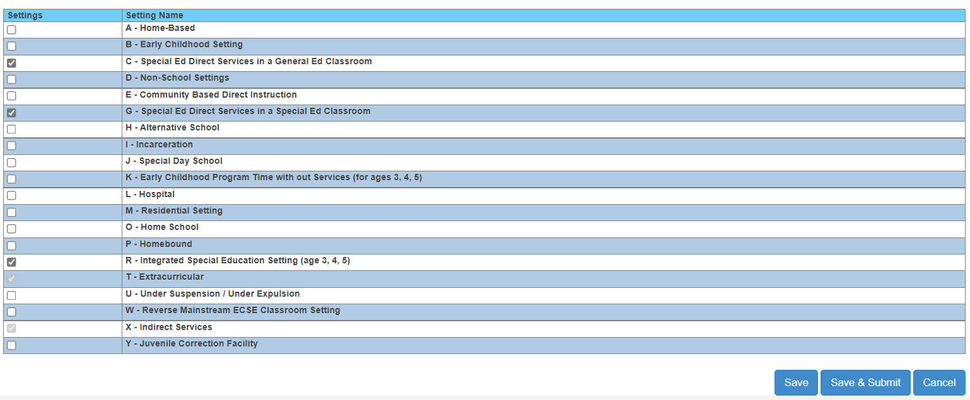

Setting has been marked

Settings in **“Summited”** status go to KSDE for review and approval.

If settings are found to be inaccurate, KSDE may decline the setting list submitted or unsubmit the setting list.

A settings list in **“Declined”** status can be revised by deleting the current settings, creating a new lust and resubmitting the new list to KSDE.

An unsubmitted settings list returns to **“In Progress”** status can be revised by choosing Edit from the Action drop down or by deleting the current settings, creating a new lust and resubmitting the new list to KSDE.

Buildings with KSDE approved settings are listed with “**Approved**” status on the settings list page.

Settings list for process for Private / parochial schools in the catchment works the same a public school.

1. Go to the settings list page.
2. Click the new button on the top right.
3. Select the parochial organization and building.
4. Mark the settings
5. Click save and submit.

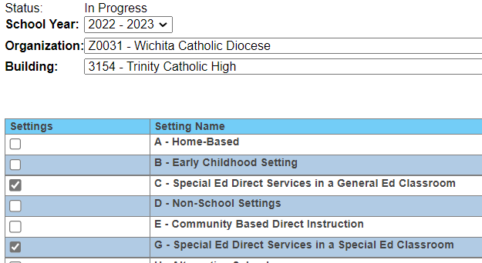

Correcting, changing or removing existing settings

Settings cannot be edited directly. Changing settings is completed on the Settings list page by building.

To edit or make corrections, the setting form must be un-submitted or deleted first.

Follow the steps above to create a new form, make changes and re-submit for approval.

Deleting a current form and entering new settings and re-submitting completes the same task.

Settings List page – selecting Actions

**In Progress** status allows the user to **View, Edit, Submit** or **Delete** the settings listed.

**Declined** status allows the user to **View, Edit,** or **Delete** the settings listed.

**Submitted** status allows the user to **View, or Unsubmit** the settings listed.

**Approved** status allows the user to **View, or Unsubmit** the settings listed.

**View** action allows the user to only view / readthe settings listed.

**Edit** action returns the setting list to **In Progress**, settings can be modified and resubmitted.

**Unsubmit** action returns the setting list to **In Progress**, settings can be modified and resubmitted.

**Delete** action removes all settings, if settings are needed, then creating a new list of settings is required.

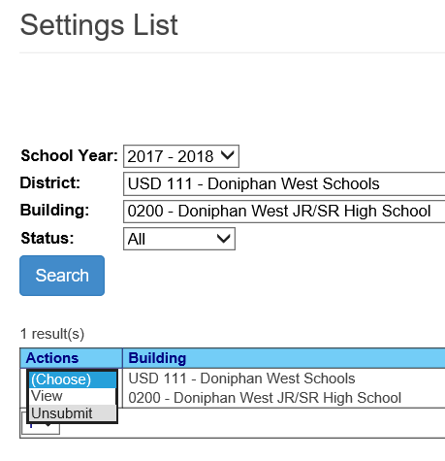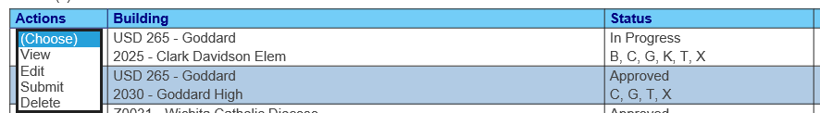

Note: Only approved settings are available for selection on service lines. If student records are imported listing an unapproved setting for the service location / attendance building, verification 0004 will trigger.

## Building Information Page

**Building information** page is found by selecting the Building Information link on the Navigation pane.

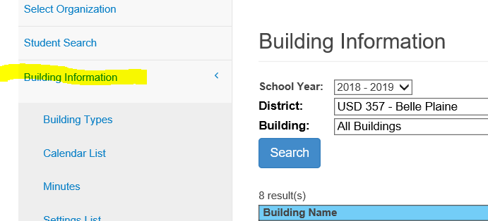

The Building information page displays all data related to each specific building from the data source. The building information is displayed by school year, organization and building selected.

Building Name and number – populate from the KSDE Directory Updates application.

Building type – populate from the KSDE Directory Updates application.

Setting code – populate from the SPEDPro settings list

Calendar - populate from the SPEDPro Calendar list

Minutes - Grade 1 -12 populate from the building’s Daily schedule in the KSDE Directory Updates application.

Minutes – Grade KG populate from the building’s KG schedule in the KSDE Directory Updates application.

Minutes – Grade Pre-K populate from the building’s Pre-K session in the KSDE Directory Updates application.

Days per week - populate from the building’s session in the KSDE Directory Updates application.

Pre – K program type – populate from the building’s Pre-K session in the KSDE Directory Updates application.

Note: Inaccurate class minutes, total minutes, days per week and preschool session types can only be fixed in the KSDE Directory Updates application. The Superintendent, Board clerk and KSDE MIS Data Manager all have permissions to make Directory Updates.

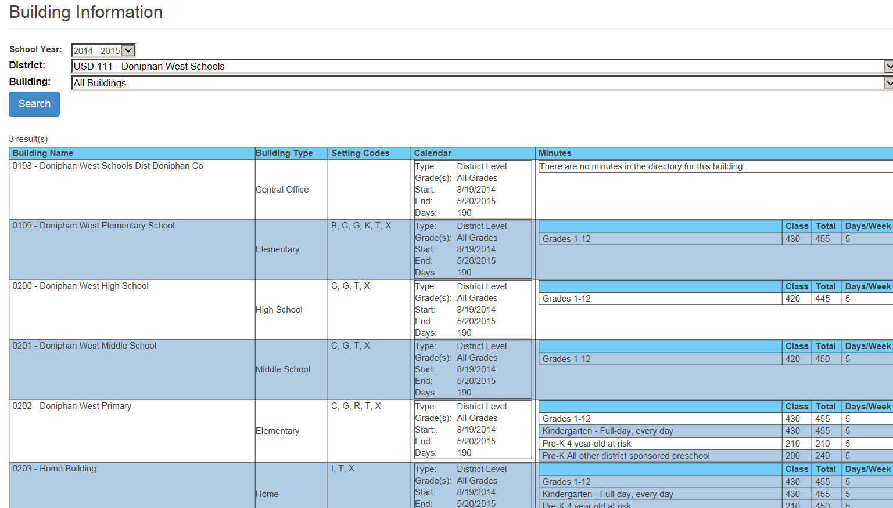

Note: Settings and program types are reviewed by KSDE for consistency before settings are approved.

Private / Parochial Schools - Accredited

Schedule’s and session minutes for Private / Parochial schools also populate pull from the KSDE Directory Updates application. If a Private / Parochial School does not complete the directory updates, contact the KSDE Data Manager with the correct current year sessions and schedules. The clock time for starting bell, dismissal bell and minutes per lunch period are needed for each program type - preschool, Kindergarten and grades 1-12. KSDE will update these in the directory and save them to the application.

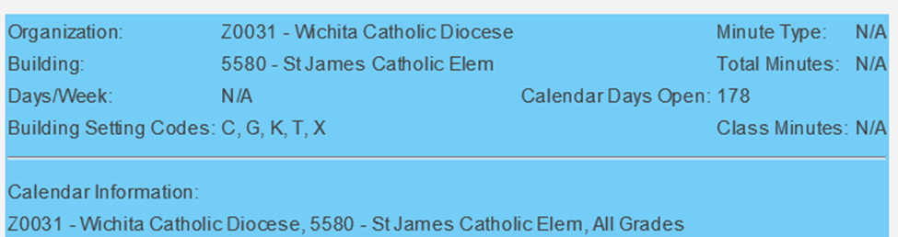

Note: Clicking the “building info” button on a service line displays in a new browser tab, the minute and days value present in the Directory (above). Values of N/A (behind the (Red Circles) indicates the directory updates are not entered for the students grade level at this building

Private / Parochial Schools – Non-Accredited

Schedule’s and session minutes for non-accredited private / parochial schools pull from the KSDE Directory Updates application, under a single Organization - X0440. The KSDE Special Education Data Manager updates the current year Directory sessions and schedules for Non-Accredited private / parochial schools. To complete the Directory Updates, the following details are needed.

Clock time for starting bell, dismissal bell and minutes per lunch period.

Each program type - preschool, Kindergarten and grades 1-12 must be sent to KSDE to update these in the directory and save them to the application.

## Personnel List Page

The Personnel list page can be accessed from the link on the Navigation n page in SPEDPro. The Personnel List is a table containing all of the licensed special education service providers and NPE contract providers in your agency. The screen below displays a sample list.

**New Providers**

A **New** person can be added to the Personnel List by clicking on the **New** button located in the top right of the screen. A new blank form will be displayed and is ready to create a provider profile.

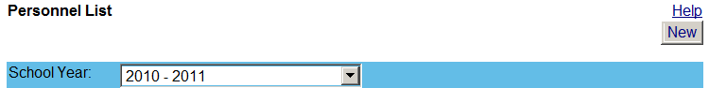

New button for entering new providers

The form allows data entry for all providers in your agency. Complete these steps.

1. Select the current school year.
2. Enter the Provider ID.
   1. Provider ID is generated and found in the Personnel Categorical Aid (PCA) application.
3. Enter the First and Last name.
4. Choose the organization of the service location where the provider works.
   1. Click Add New Organization
5. Mark the provider role for the organization chosen.
6. Repeat the process if the provider servers’ students in multiple organizations.
7. Save the provider profile.

Note: The role of Non-Public Equivalency (NPE) provider only applies to organizations claimed for NPE reimbursement

Service line provider roles is required for all providers listed

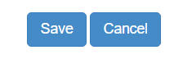

Only mark the organizations of buildings where the provider serves students.

Remove organizations where the provider does not serve students.

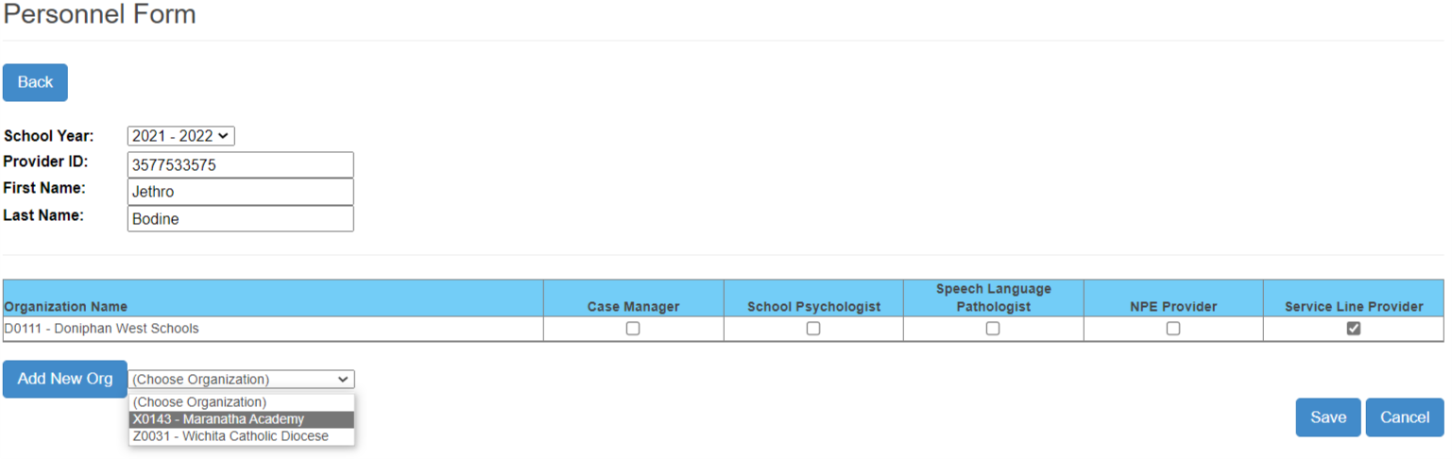

Provider roles are assigned by individual service organization.

**Inactivating Providers – Fixing providers with incorrect ID numbers**

1. Remove your districts from the marked organizations at the bottom of the profile by removing all roles associated to the provider.
2. Save the record.
3. Recreate the provider profile anew with the correct ID, roles, and assignments then save the record.

Click on **Edit** from the drop-down arrow to the left of the person you wish to make changes in the information to. Once the changes have been made, click on **Save**.

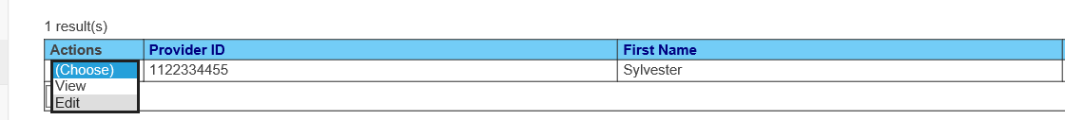

**Promote Providers – to the next school year.**

This task moves selected providers from the prior school year to the current school year.

1. At the select organization page, select the target organization click GO.
2. Navigate to the Promote Personnel link in SPEDPro.

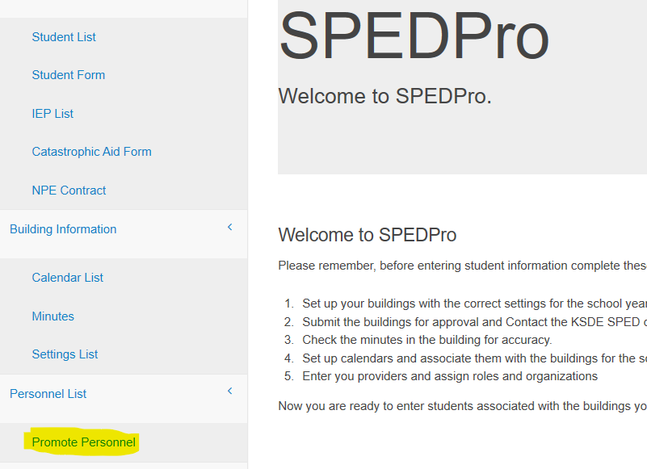

1. Click – Get Personnel

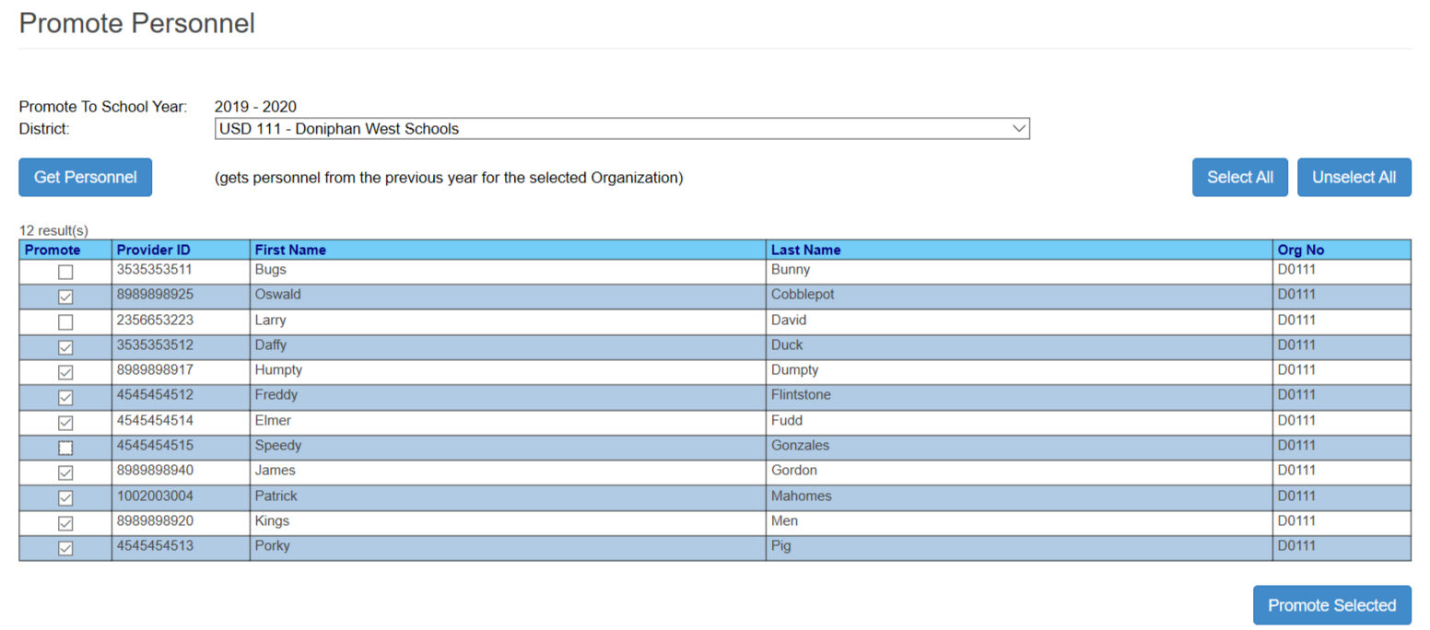

1. Mark individual providers to promote
2. Click Promote selected

# Part VIII: Data Entry

## Student Search

The Student Search link is found on the navigation pane.

Search Criteria: Search results can be narrowed by filtering the search criteria to specific values. The results returned will only display students meeting the search criteria. Click the Search button for desired results.

* The default search is preset by the school year and organization chosen on the **Select Organization** page.

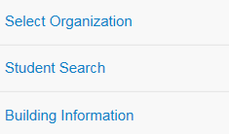

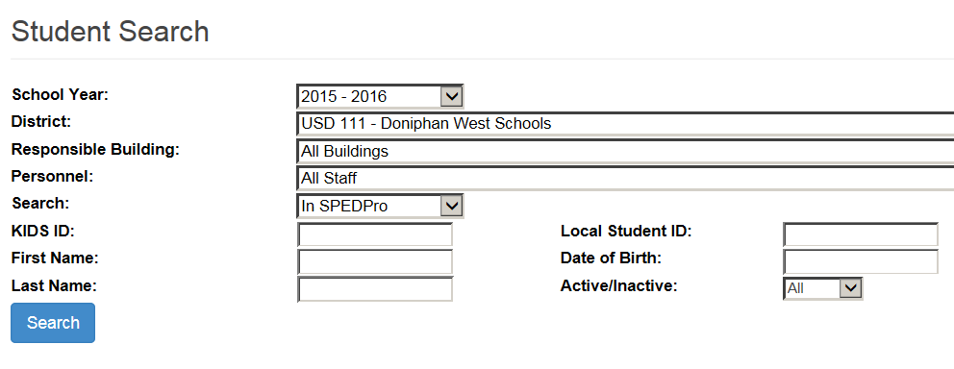

Users with district-level access will have the option of selecting the building to help narrow the search criteria for a student. School-level users will not have this option and will only be able to search for students associated with their school.

Default search, no additional criteria entered: Returns all students in SPEDPro for the school year chosen.

School Year: Keep default school year or chose a different school year using the drop down value list.

Disitrct: Keep default organization or chose a different organizaton using the drop down value list.

Responsible building: Keep default All buildings or chose a specific building using the drop down value list.

Personnel: Keep default All staff or chose a specific provider using the drop down value list.

Search Database: Keep default search for SPEDPro records or choose search for KIDS collection records.

KIDS ID: Search by the student’s 10-digit KIDS ID number

First Name: Search by the student’s First name

Last Name: Search by the student’s Last name

Local ID: Search by the student’s local ID, if a local ID is present in the KIDS Collection records

Date of Birth: Search by the student’s date of birth present in the KIDS Collection records

Active / inactive status: Search by All student profile status code or chose active / inactive.

Note: For every different search value entered, each value must be an exact match for a successful result to be found. If any of the search values are not found, the search result will be zero records found. For example, if search on KIDS ID, last name & data of birth is entered but last name is misspelled, no results are found.

New students - If the student is accounted for in KIDS system by the responsible agency, then the student can be entered into SPEDPro, if not then a KIDS record must be submitted by the responsible agency to the KIDS collection system before the student can be entered into SPEDPro.

The number of search results displayed can be expanded by increasing the page size. For example, a page size of 100 will display up to 100 records per page.

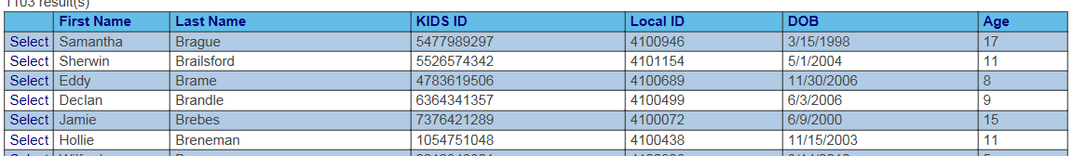

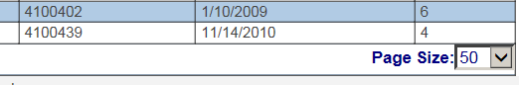

The Page Size will return the number of rows of data listed on the page as selected.

## Student “Profile” List

Once the student search is complete, then results display the students meeting the search criteria. Selecting the student takes the user to the profile list.

Click on the blue *Select* link once you find the correct student.



New Profile

To create a new profile for a student, find the student first and navigate to the *Student Profile List* screen. Click on **New**, located in the upper right area of the screen to create a new profile.

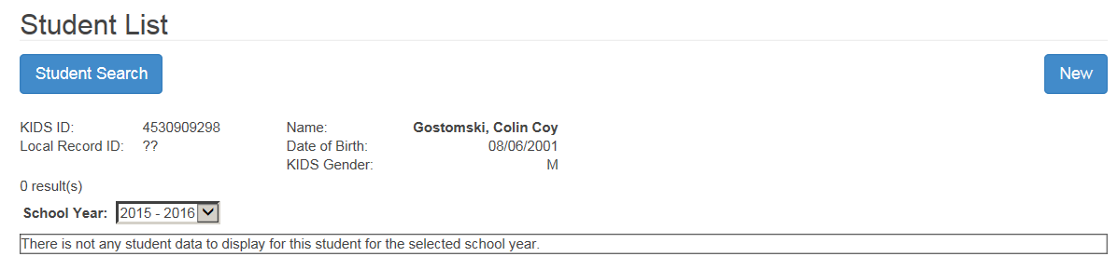

Complete the form utilizing the dropdown arrows where provided and entering the rest of the data. Click on “**Save”** when you have finished entering all the information for this profile.

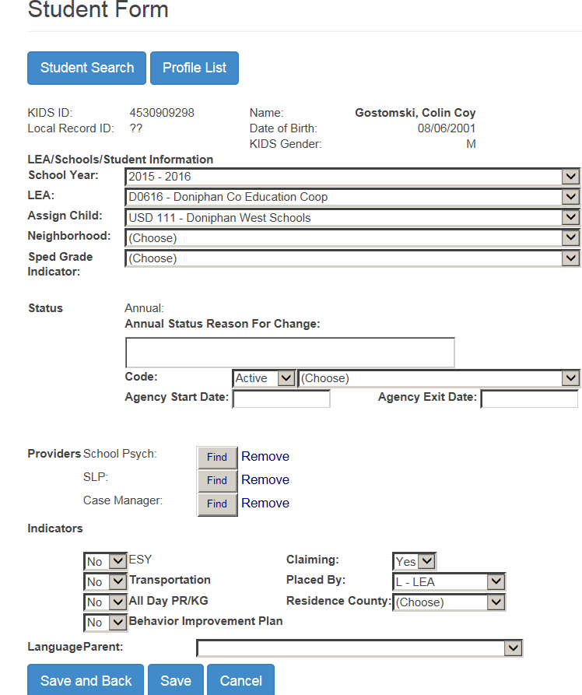

Once you have created a new profile and saved it, you will return the Student Profile screen.

The following are the Actions available with a profile: View Profile, Edit Profile, View IEPs, Cat Aid, and Delete Profile.

Profile Function

It is the student profile that links the student to a given organization for a given school year. The profile acts as the header record for which all other data associated to the student is connected to. This includes the IEP and service lines, NPE contracts, catastrophic aid applications. If a student profile is deleted for a school year, then all other data related to the profile is also deleted. The action of deleting a student profile will completely remove the student and all data from the organization for the school year.

Profile Actions

### 

**View Profile**

Choosing **View Profile** action will display the student Profile data. The page is view only, the data can not be edited. If the information needs updating, click on the **Edit** button located at the lower right corner of the screen. You will be directed to a screen with editable fields.

**Editing Profile – changing existing profile data**

Choosing **Edit Profile** action allows the profile data fieldsto be editable using the drop-down arrows to select new values. Permitted values will be available for selection. After updates are complete, click Save or click on Cancel to return to the Profile List screen without saving changes to the profile.

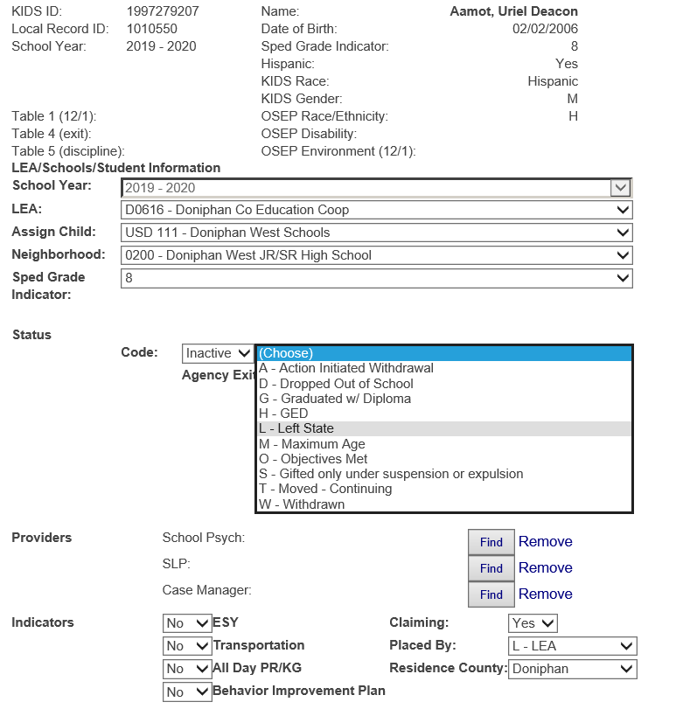

Delete Profile

Choosing **Delete Profile** action option will permanently remove the student profile, IEP, services and all record of the student for the school year. If selected, you will see a pop-up window that verifies that you really want to delete the profile. Click on **OK** to delete the Profile permanently or **Cancel** to stop the deletion and return to the Profile List screen. Deleting the profile will totally remove all other pages of information associated with the student for the school year, including IEP and services.

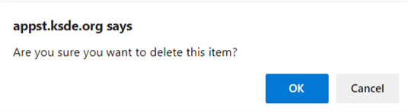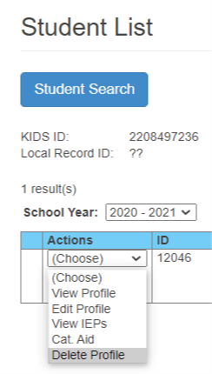

Warning: Be sure you are deleting the correct profile in the correct school year. If a profile from one school year appears in a different school and it is deleted, it will be removed from the school year list on the profile and the target school year. Be sure the target school year and the profile are the same

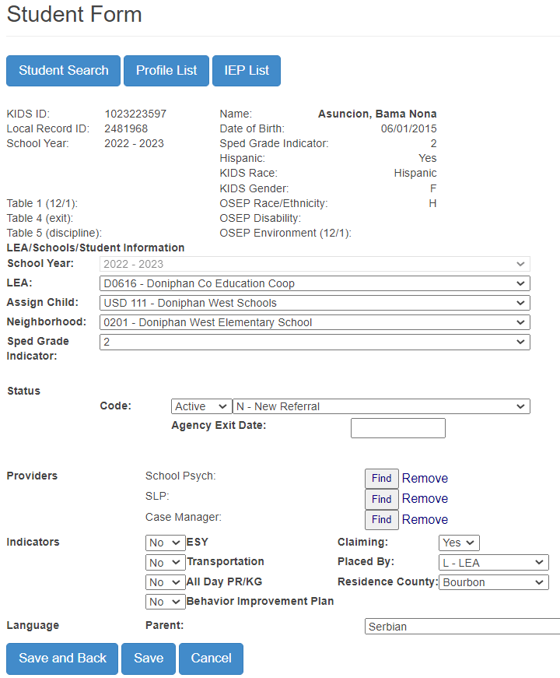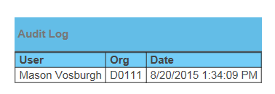

Audit Log

At the bottom of the student’s profile, there is an audit log for this profile. Showing the history of changes to the record by User, Organization and date stamp.

Private / Parochial students

Private / Parochial students are identified by the Organization and building listed. Select the Neighborhood (X0 or Z0) Organization from the drop down. Next select the appropriate school under the organization where the student is enrolled for General education.

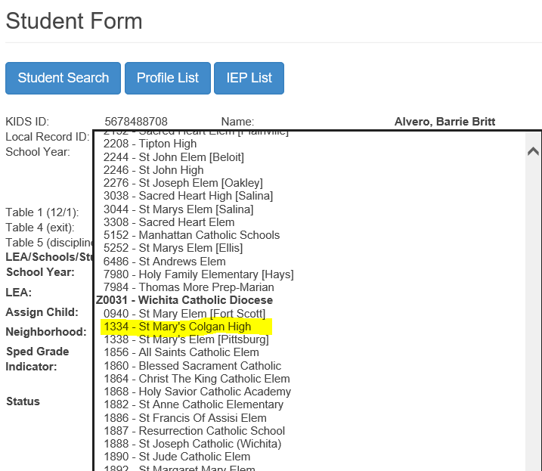

## IEP List

Choose the **View IEPs** action from the dropdown list on the Profile List screen to navigate to the student’s IEP page.

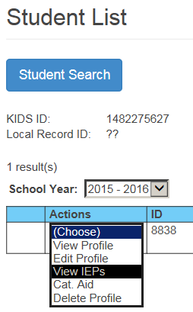

On the student profile click on the **IEP List** button at that top to navigate to the student’s IEP page.

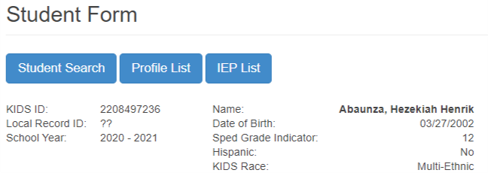

Either method will take you to the same location which is the View IEP List screen that should be similar to the one shown below. The Actions available for each IEP are: View SLs, New SL, New Comment, Edit IEP, Copy IEP, and Delete IEP.

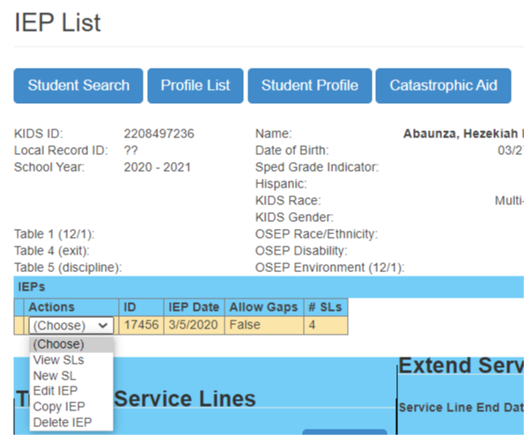

New IEP

To create a new IEP, click on **New IEP** button in the top right of the IEP List screen.

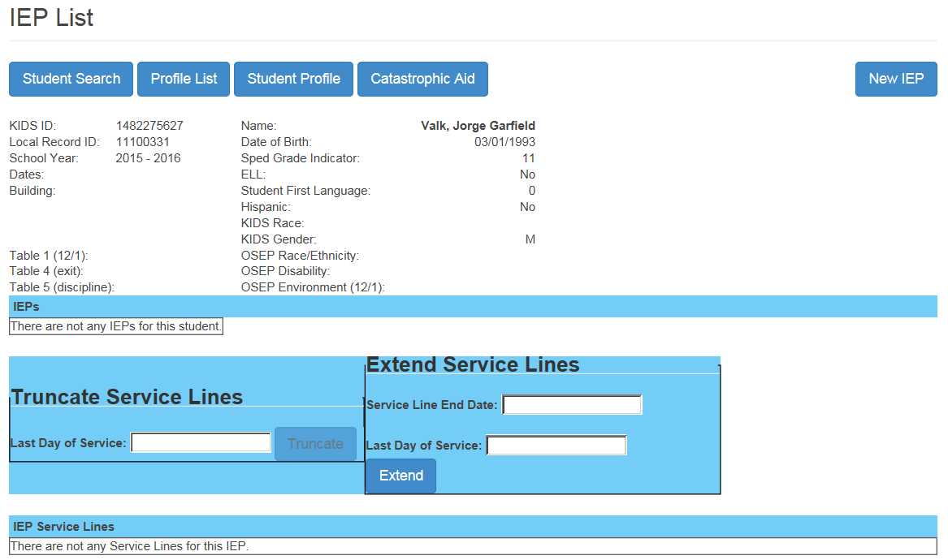

A new box will be displayed that will provide a space to enter the IEP date. A drop-down calendar will appear when you click on the date. Enter or select the day and then click on **Save**.

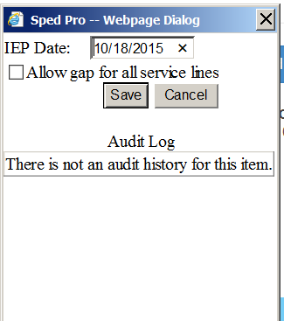

Edit IEP

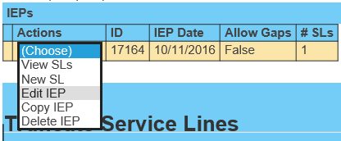

Edit IEP enables changes the IEP date or the Allow Gap status. From the IEP Action menu, you have the option of modifying the IEP. Click on the down arrow to the left of the IEP that needs editing and click on **Edit IEP**. A pop-up Dialog box will appear displaying the Audit Log and the option of changing the IEP Date or marking Allow Gap. Enter or select the new values and then click “Update”.

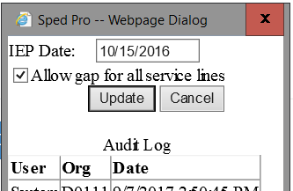

Gaps in Service

A gap in service occurs under this condition.

A student receives IEP services during the current school year, then exits.

As a result of exiting, all IEP services cease.

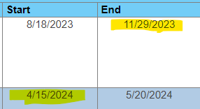Later in the same school year, the student resumes IEP services. This creates a Gap in services and triggers Verification 0146 & 0169

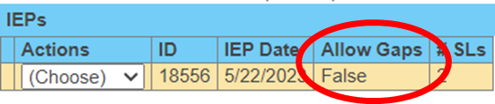

To resolve the verification, edit the IEP,



mark the “Allow Gap” indicator and update.

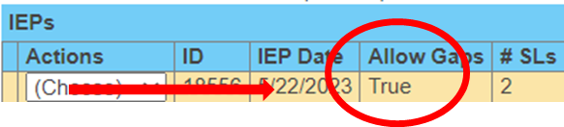

Delete IEP

To delete an IEP, click on the down-arrow to the left of the IEP to be deleted and then click on **Delete IEP**. Next a prompt box will require you to verify that this IEP should be deleted. Click on **OK** to delete or **Cancel** to return to the IEP List screen without acting.

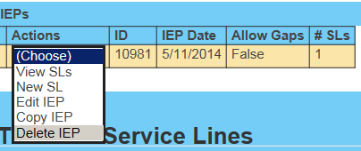

## Service Lines

New Service Line

From the IEP List, select New SL from the dropdown list of the IEP. A screen similar to the one below is displayed. Fill in the Anticipated Services section and then click on **Save**.

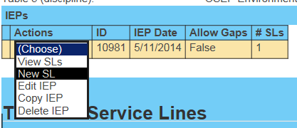

Some students will have multiple IEPs. When the View IEP List screen is accessed, the IEP list is displayed below the Student Information section. Below the IEP list is service line information. When there are multiple IEPs, the service line displayed initially will be the service line(s) for the first IEP. To view a list of service lines for a different IEP, click on the down arrow on the IEP line and select **View SLs**.

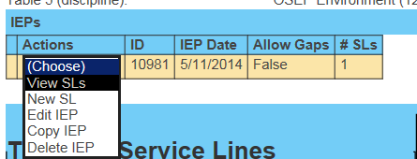

**Service line detail**

Service Organization – enter the LEA of attendance building / service location.

Service building – enter the attendance building or service location.

Primary building – (optional), - select YES for use on reports such as rosters etc.

Responsible building – Student’s Accountability school

Primary Disability – as designated by the IEP team.

Secondary Disability - as designated by the IEP team.

Gifted Indicator – Status of participation in a Gifted Program

Setting – the code representing the program or environment present in the service location

Service – the code for the type of service the student receives in the service building.

Start date – the first day the service becomes effective in the school year.

End date – the last day the service is delivered in the school year.

Frequency – how often is the service delivered, weekly, bi-weekly, monthly, etc.

Total days – the total number of school days the service is delivered between the start and end dates.

Use only 1 of 2 options to arrive at total days.

Report only total days from the IEP.

Report Days per week and frequency and SPEDPro will calculate total days from the calendar.

**View Service Line**

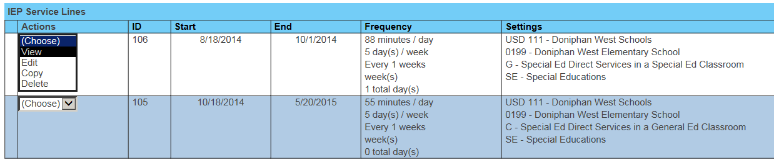From the list of IEP Service Lines, the Actions are to View, Edit or Delete the line.  
The Student Information is listed at the top followed by the Anticipated Services section. Below that will be a list of errors on the Service Line, if any. The final section displays the Audit Log if there has been any activity on this Service Line.

Choose service line to View

Edit Service Line

Text is not editable from the View screen. Click on Edit in the lower right corner to access the Edit Service Line screen. OR from the IEP List, choose Edit from the Service Line dropdown arrow. The text is now editable to make any necessary changes to the Anticipated Services section and then click on **Save**.

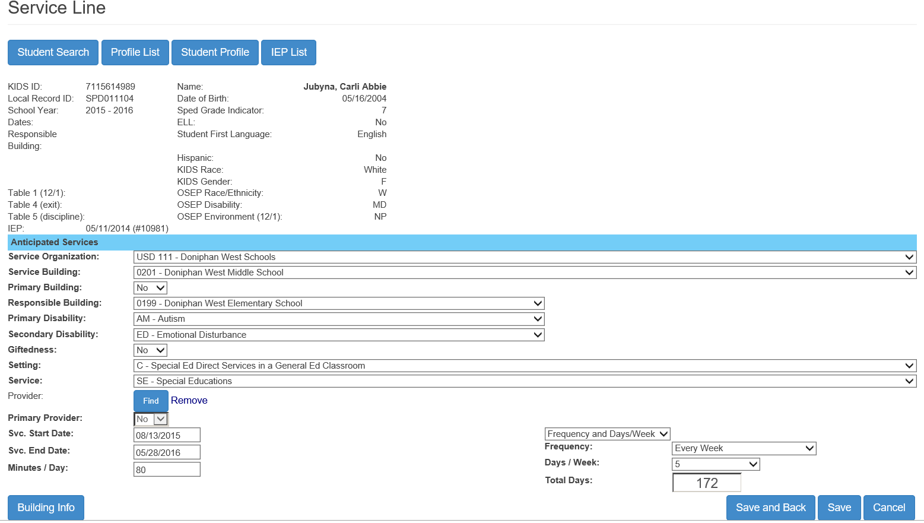

Area of Disability  
Gifted status

Service location  
Responsible school

OSEP Categories

Student Information from KIDS

Service Frequency  
Total Days of Service

### 

Audit Log

Delete Service Line

To delete a service line, from the IEP List choose **Delete** from the Service Line dropdown arrow. You will see a screen that verifies that you really want to delete the service line. Click on **OK** to permanently delete the service line or **Cancel** to stop the deletion and return to the IEP List screen.

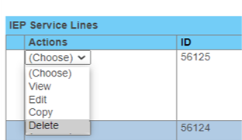

Service location data

Calendars and Directory data can be viewed for service locations by selecting the building info button for the target service line

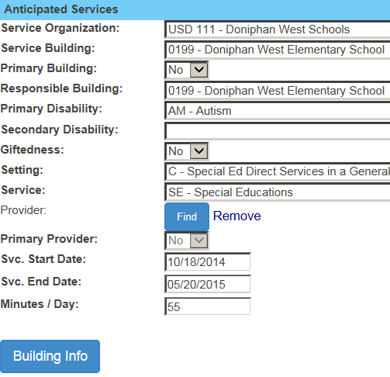

Calendars and building schedules open in a new tab in your browser

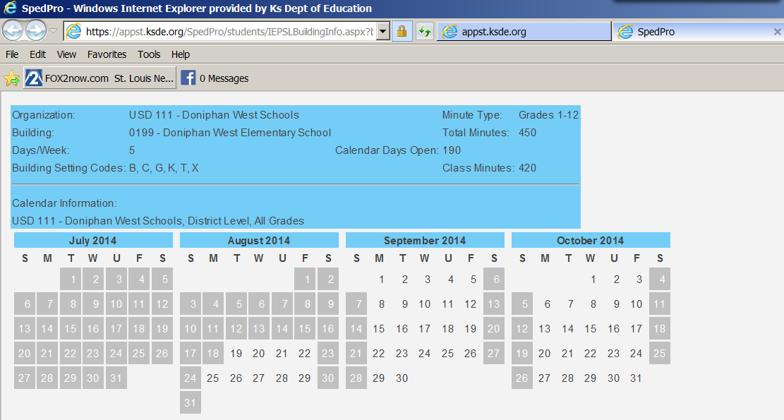

**Service Minutes**

Service minutes are established in the KSDE Directory Updates application. The minutes have a maximum value equal to the Class minutes of the session as listed in the Directory. For example, A grade KG student is limited to the amount of Class minutes of the KG session for the service location.

Note: If the student receives IEP support during the lunch period, then a separate service line is required to account for the lunch period minutes. This is reported separately because the lunch period is not included as part of the accredited school day, thus not counted as class time minutes in the State Directory.

Modifying Service line End Dates

Service line end dates can be modified on the student’s IEP page by an individual service line or several at a time by truncating (shortening the number of days of service) or extending (lengthening the number of service days) by using the Truncate or Extend Service Line tools.

Truncate Service Lines – Service lines can be truncated when services actually end before the anticipated end date. Such as a student exited or their IEP has been amended and some services cease. The user selects the new Last Day of Service. This date is applied to every date after the new Last Day of Service. Total days of service are recalculated based on this new date.

See example below.

Truncate Service Lines will only change the 05/20/2015 date to 11/25/2015.

The date of 10/01/2014 will not change.

Extend Service Lines - a service line or group of service lines can be extended when services actually continued beyond the anticipated end date. Such as a gap in services occurred because the next IEP of the school year was more than 365 days from the prior IEP. A student continued to receive services to the end of the school year on an IEP that was more than 365 days old.

Enter the service line end date to extend. This is the Target date.

Enter the new end date for those with the targeted dates to be extended.

Chick the Extend button

See example below.

Extend Service Lines will only change the 10/01/2014 date to 10/17/2014.

The date of 05/20/2015 will not change.

Verification 0169 – Gap in service

The Extend Service Lines tool can be used to resolve verification 0169 in cases when a student did not exit and return to the same service organization.

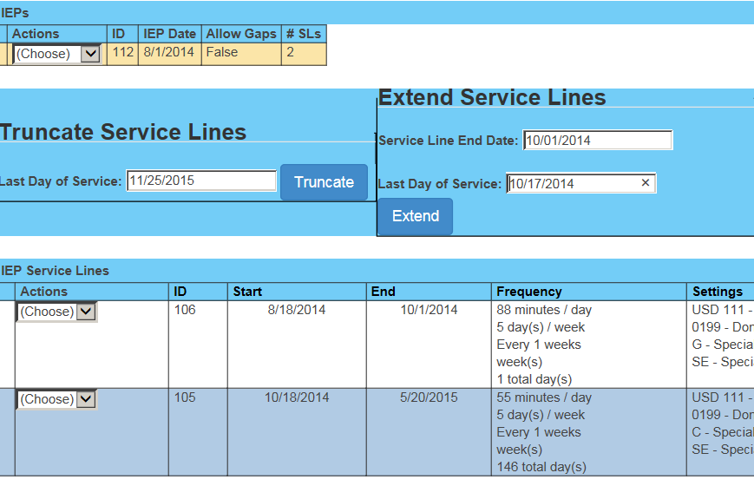

Students who move between Coop / Interlocal member districts during the school year

Because students who move between member districts never leave the organizations catchment, these students are not considered exits. All that is required is updated service line data and an updated student profile.

1. End the first set of services lines as of the last day of IEP services in the first organization.
2. Create new service lines starting at the new service location and responsible school.

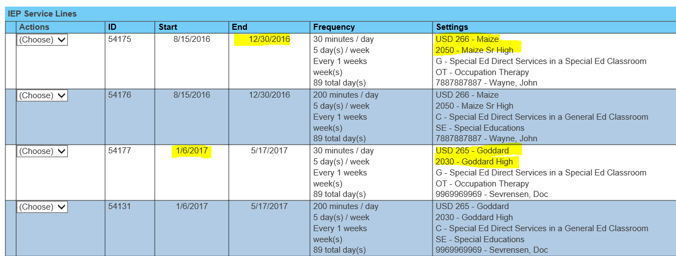

1. **If the move between schools creates a gap between calendar days, next edit the IEP, then mark Allow Gap,** click “Update” to save.

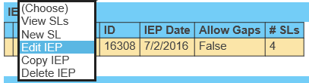

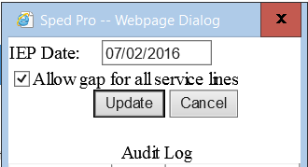

1. Go to the Student profile and change the Assign Child Count district and neighborhood school to the current district and building and save it.

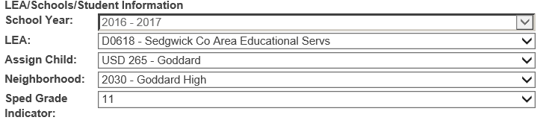

## Gifted students exiting IDEA / Part B services

This scenario would be a case of an IDEA student who had a disability at some point during the school year, exited IEP services then continued with or, began to receive only “Gifted” services. Because the student exited IDEA, the student is no longer considered a student with a disability and may qualify for the IDEA Table 4 Exit report.

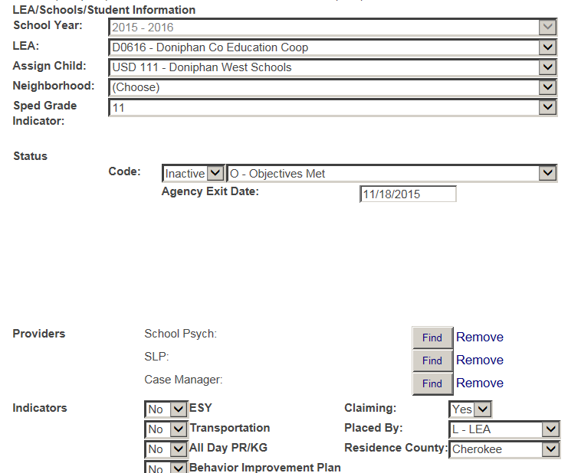

On the student profile, enter the last day IDEA services were delivered as the exit date, then make the status inactive with the actual basis of exit.

On the service lines with an area of disability present, enter an end on these service lines. Align the service end date to equal the exit date from the profile. See example, service line 1 below.

On service lines after the exit date, list only Gifted services for the remainder of the school year. See example, service line 2 below.

Note: Verification 0072, Service start date is after the student’s exit date, has been turned off and should not display in this scenario.

Service line 1

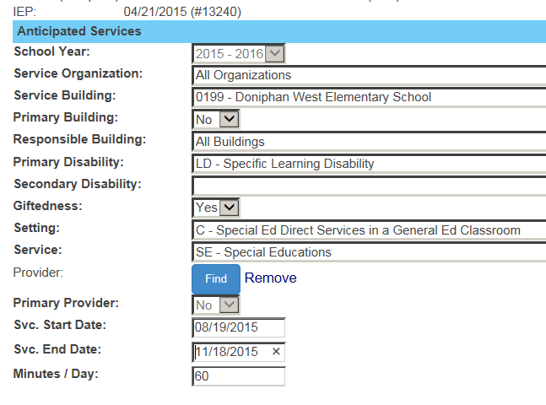

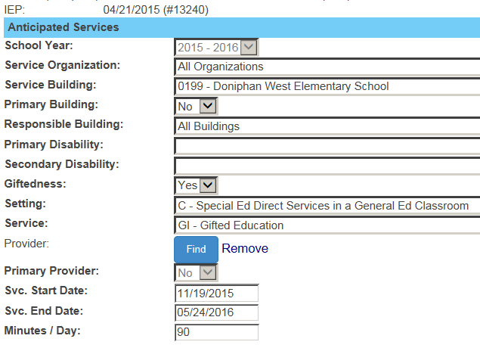

Service line 2

# Part IX - Verification Overview

**Running the verification routine:**

The Verifications page is found by clicking the Verification List link on the navigation page.

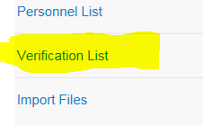

SPEDPro runs verifications by the search criteria selected.

Clicking the search button with default settings listed will return every student with every unresolved verification for the default school year. Depending on the number of students with verifications, the default search may take longer to return results than a search by specific criteria such as ID number or flag.

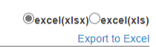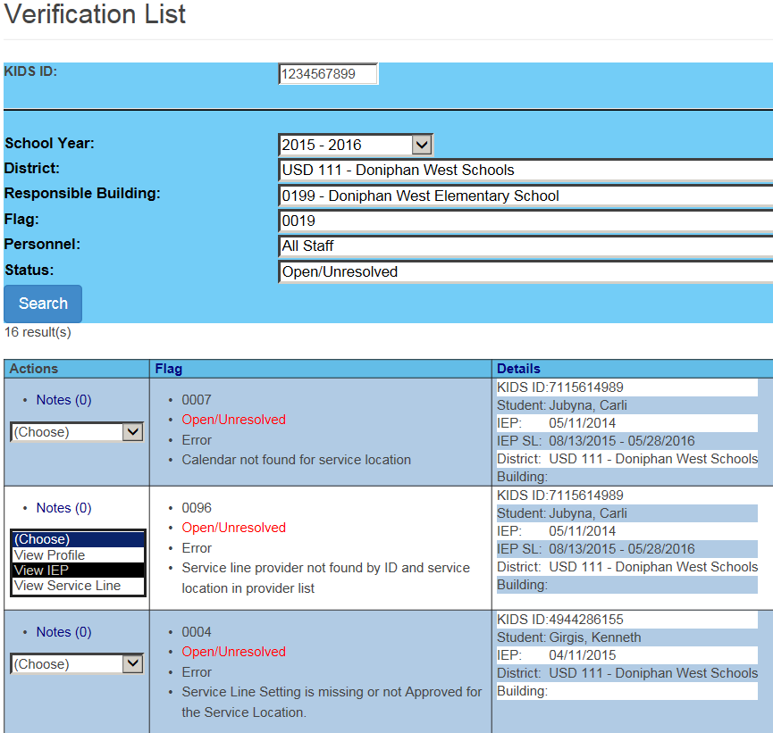

➑

➏

➐➏

➏➏

➎

➍

➌

➋

➊

Selection of search criteria will return different results. Verifications can be filtered by selecting the subset criteria

➊ Search by KIDS ID number. Search results will only return verifications triggered by this student.

➋ Search by District. Search results will only return students with verifications and the selected district is found on the student’s profile as the Assign Child Count (ACC) organization.

➌ Search by Responsible school. Search results will only return students with verifications and the selected responsible school is found on the student’s service lines.

Note: verification results may be skewed if the student has multiple responsible schools in the school year. The verification logic will apply only to the school selected and display results based on that building.

➍ Search by Verification Flag. Search results will only return students with the selected verifications flag.

➎ Search by Provider. Search results will only return students with verifications and the selected provider is found on the student’s service lines.

➏ Search by Open / Unresolved verifications. Search results will only return students with verifications that have not been resolved or corrected in SPEDPro.

➏ Search by Closed / resolved verifications. Search results will only return students with verifications that have resolved or overridden by KSDE. Verifications that have been corrected and pass the verification test are moved to the resolved category

➐ Export verification list to Excel. Verification results can be listed by student by the default search (all verifications) or by the resulting subset of students by selected criteria. Excel files can be sent to providers for guidance for data correction or notification of inaccuracies present in the local IEP system.

➑ Verification action. Use the Action options to see specifically what is triggering the verification flag.

View Profile – navigate to the student profile triggering the verification

View IEP - navigate to the IEP triggering the verification

View service line - navigate to the service line triggering the verification

**Verification Strategy**

When investigating verification, it is important to follow the logic in the verification description know what is being flagged. Then you go from the verification page to the corresponding data fields in SPEDPro, note how the values reported relates to the verification description.

For example, verification 0144 descriptions reads -

•Student did not receive services on his/her exit date. Please align service end date and exit date to be equal

Check the 2 things in the alert description

Service end date – on the service lines

Exit date - on the student profile

Use the navigation drop downs to view the values triggering the verification.

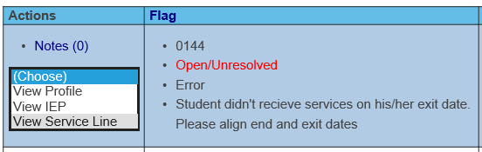

The last day of services reported is 3/20/2017,

Relevant question: Why do services stop on 03/20 and not on the exit date?

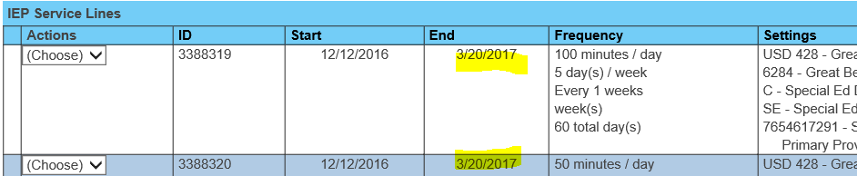

Use the navigation drop downs to view the values triggering the verification.

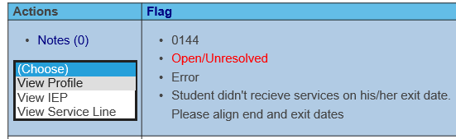

The Exit date you are reporting is 5/18/2017



Note the values triggering the verification and proceed with a fix

Verification List

List addressing errors and exceptions are displayed via the Verification List. To access the list, use the navigation pane on the left side and click on **Verification List**. The Verification list will display a list that, by default, displays all open or unresolved issues. A screen similar to the one below will be displayed.

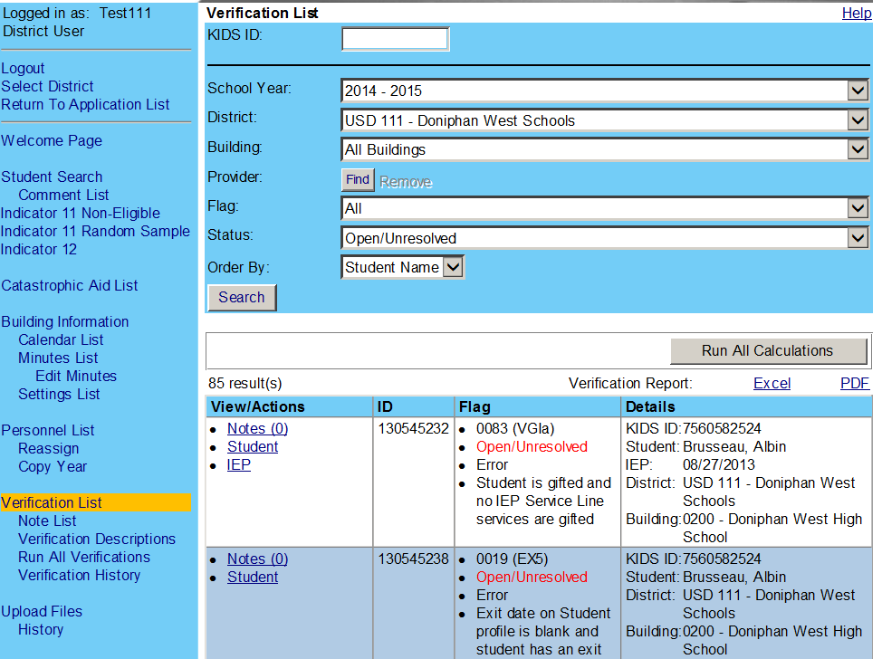

This one is Open/Unresolved

The top portion of the screen provides various fields to enter search criteria to narrow the number of verifications listed. Once the criteria have been entered or selected, click on **Search.**

Verifications can be exported to Excel as a report for provider input or respond to KSDE

**Troubleshooting Tips – How to investigate specific verifications.**

**Verification 0011** – Days of service are blank, zero, or exceed building maximum or exceed the range between the start and end dates.

Step 1 – Check the service line triggering verification 0011.

Step 2 – Choose to edit the service line.

Step 3 – Upon opening, the application automatically recalculates the total days. > Save

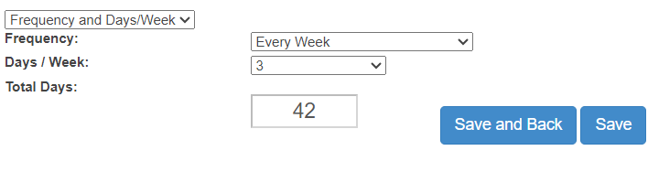

**Verification 0053** - Age of student is outside of the 3 to 9 range per service line dates for current school, with DD disability listed.

Step 1 – Check the IEP triggering verification 0053.

Step 2 – Note the student’s birthdate and when the student turned age 10.

Step 3 – Compare the birthdate to the date range of services.

Note: The Developmentally Delayed disability is present beyond the student’s 10th birthday.

If the student is not identified with a new disability category by the 10th birthday, then the student’s eligibility for IDEA services ends on 8/23/2023 (in this example)

Step 4a – An evaluation is completed, and the student no longer qualifies for services under the IDEA. The student profile is updated with the basis of exit.

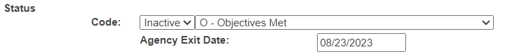

Step 4b – An evaluation is completed, and the student is found eligible under a different disability category.

Enter new IEP and mark the “Allow Gap” indicator to confirm lapse is service for the time the student was ineligible.

Using Reports for Verification and Data Quality Checks

Several SPEDPro reports are to be used for Verification of Data and Data Quality. Monthly reminders (FAQ) from KSDE list reports that are to be analyzed for verification with a specific data quality focus.

These reports include:

|  |  |  |
| --- | --- | --- |
| Projected End of Year Report | Projected December 1 report | Projected Discipline report |
| Overlap report | Projected Table 4 Exit report | Projected Table 5 Discipline reports |
| Exit status report | Unknown Exit report | Unresolved Exit report |
| Incidents omitted from the OSEP Table 5 Discipline Reports | | Unclaimed student report |

**Projected reports**

Use crosschecks between corresponding data points. Look for unexpected or illogical comparisons.

Illogical Exit date, Example 1 – Using the Projected End of Year report. Search for students with unequal Agency Exit date and Latest Service end date. This may indicate services actually ceased before the service line end dates.

Incomplete data, Example 2 – Using the Projected End of Year report. Search for students with No / blank Agency Exit Date and Latest Service end date is before the last day of school. This indicates that the current IEP covering the remainder of the school year is missing or the Exit Date and Basis of Exit need to be entered.

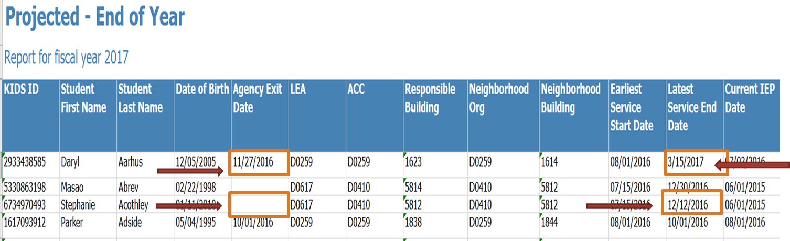Validation Crosschecks

2

1

Projected December 1 report – run from beginning of school to February 28.

1. OSEP Disability = DD and December 1 Age is age 10 or greater
2. All settings contain “B”, “R”, “W” for students grade 1 or higher.
3. December 1 age and grade level are extremely distant. Grade level + 5 should be equal to or + / - 1 of each other. Grade 3 + 5 = 8-year-old. Ages 6 and less or 9 and greater may indicate an incorrect birthdate in KIDS or incorrect grade level.

Projected End of Year report – run throughout the school year.

1. Exit Date is blank and latest service end date is before the last day of school.
2. Exit Date and Latest end date are not equal for IDEA students.
3. OSEP Disability = DD and December 1 Age is age 10 or greater
4. Current Status = “M” and December 1 age is 19 or less
5. Current Status = “S” and Primary and OSEP Disability is present.
6. All settings contain a “Z” value in the student record.
7. All Services has blank values.
8. Grade level has blank value.
9. Neighborhood school has blank value.
10. Assign child count lists a X0 or Z0 organization (invalid responsible school)
11. Values indicate inaccurate demographics in KIDS data.
    1. Student age is less than 2 or greater than 21 (Inaccurate birthday)
    2. Missing race / ethnicity

# Part X: Importing Files

SPEDPro provides an import process to submit student data without keyboard / manual entry. Records can be imported by individual record or as a batch file containing multiple records. The KSDE Special Education Individual student data report preparation and Data Dictionary contains the import file specifications. Records intended for import must be formatted according to the import specifications. The Data Dictionary will be your guide to ensure the file is in the correct format.

To Import records into SPEDPro, follow these steps.

1. Export the file from the local data source.
2. Name the exported file with a recognizable title.

Once you have a file ready to upload, click on the **Import Files** link in the left navigation pane.

1. Select the file type to be imported.

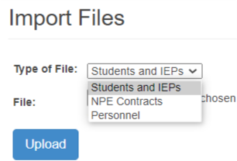

1. Select Choose file and use the pop-up window to browse to locate the file to be imported.
2. Highlight the file to import and select open. Once selected the pop-up window will close.

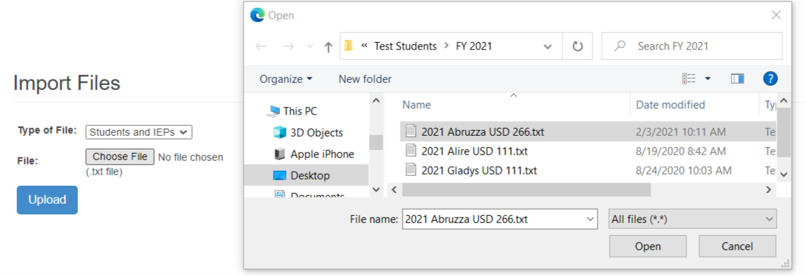

1. Once the file is chosen, the file name appears next to the choose file button
2. Click Upload to import the selected file into SPEDPro.

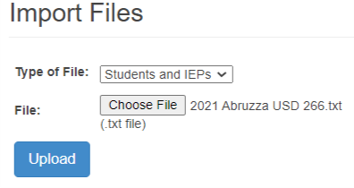

Import History

The history page displays a list of files that have been imported to SPEDPRO. The user that imported the file, the date and time, the file name, the total record count, successful records and import alerts.

**Import Alerts**

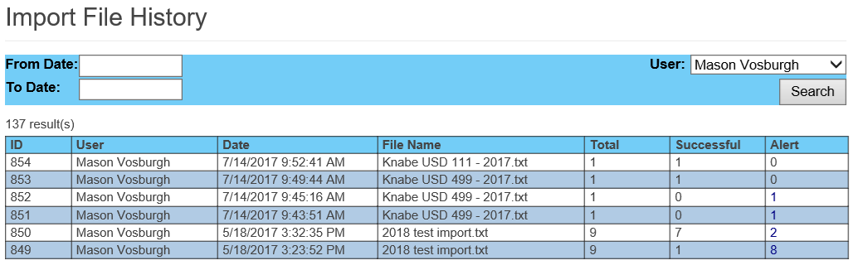

If imported files have an issue, you will see the number of alerted records in the “Alert” column.

Clicking on the alert number, a command to open text file will display.

The text file will open in notepad.

The reason for the Alert is listed in the error description column, followed by the data submitted  
Note: An Alert is not an indication that the record failed to Import. The “Error Description” provides the reason why the Alert was triggered.

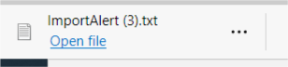

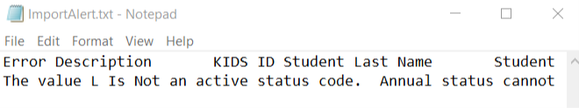

To easily read the details and see the any discrepancy in the fields, copy the Text from notepad and paste into Excel. Excel will align the data in rows and columns. A SPEDPro Import template is available to paste Import alerts. This will allow you to see the alert description and the record values to discover the value triggering the verification alert.

@www.ksde.org - on the MIS and student data page

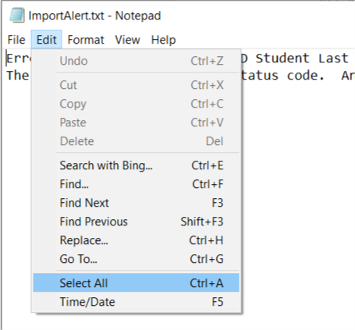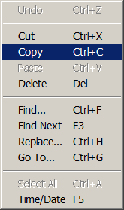

An Alert may simply be a warning such as values in the file do not match to KIDS records. There may be 1 or more reasons causing the alert.

Check the student record after Import to see if the Import was successful and if the Import created duplicate records.

# Part XI: Non-public Equivalency Contracts (NPE Contracts)

Some students will have services provided by external agencies and their providers under a non-public equivalency contract. To enter / view those NPE contracts, go to the **student’s Profile**. The link to the NPE form is found on the navigation pane to the left. Select the NPE contract link to open the form.

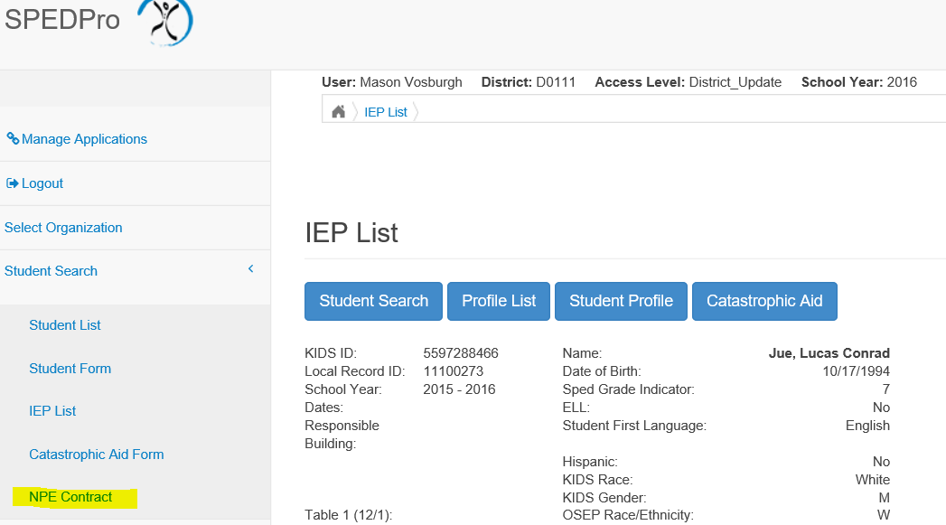

Click the New button, the form appears on screen, click new for each contracted service and enter each contracted service individually and save

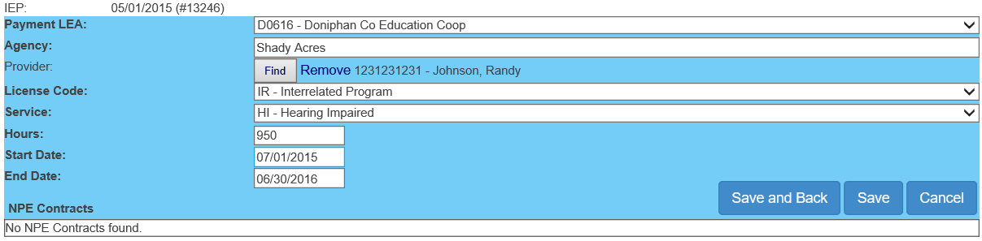

Completed contracts appear below the blank service form, with additional actions under drop down menu.

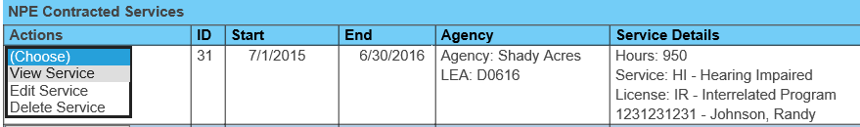

View NPE Contract

View an existing contract. Under NPE Actions, select **View** Service The form appears for viewing.

Edit NPE Contract

To edit a contract, select **Edit** service under NPE Actions. The original form appears with the data fields open for editing. You are able to make changes by filling in the form utilizing the drop-down arrows and open text fields. When the form is complete, click on **Save** to keep the changes made to the contract. **Cancel** will keep you on the service form page without saving changes.

NPE Providers

Note: the only providers available for selection are those marked in personnel are those with NPE provider roles.

Delete NPE Contract

You are able to delete a NPE service. You will see a screen that verifies that you really want to delete the service. Click on **OK** to permanently delete the service or **Cancel** to stop the deletion and return to the NPE form page.

To delete an entire contract, each service must be deleted individually

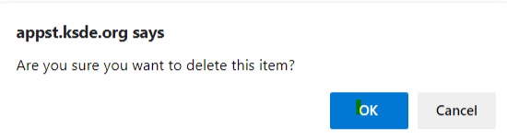

**Kansas State School for the Deaf and School for the Blind Summer session**.

If a student is participating in the KS State School for the Blind or School for the Deaf summer session and your USD, Coop or Interlocal is billed for participation in the program, then the student can qualify for NPE reimbursement. Additional steps, such as creating a student profile for your organization, may be needed to make the claim

1. If the student is not claimed in KIDS collection by the student’s home / neighborhood USD, then a KIDS record will be required before the USD, Coop or Interlocal can access the student in the MIS to enter the NPE data in the MIS.
   1. Request the KIDS administrator at KSSB or KSSB to submit a KIDS record (ASGT type) with the Neighborhood school listed as the students funding school. This will give permissions to the student record.
2. Once a KIDS record is present, search for the student using the “In KIDS” filter
3. Select the student, create a new student profile as instructed above (Part IX).
   1. Mark the claiming status as “Not Claimed”
   2. Assign child count, neighborhood school, grade and status are required.
   3. Save the profile
      1. Optional - Click new IEP and save an IEP with the student’s current IEP date
         1. Do not enter service lines.
4. Complete the NPE application as instructed above.
5. Do not create an IEP or Service lines on the IEP page. Only a student profile needs to be created.

Students claiming NPE for the KSSB or KSSB summer programs do not have IEP data. The NPE contract can be accessed from the student profile

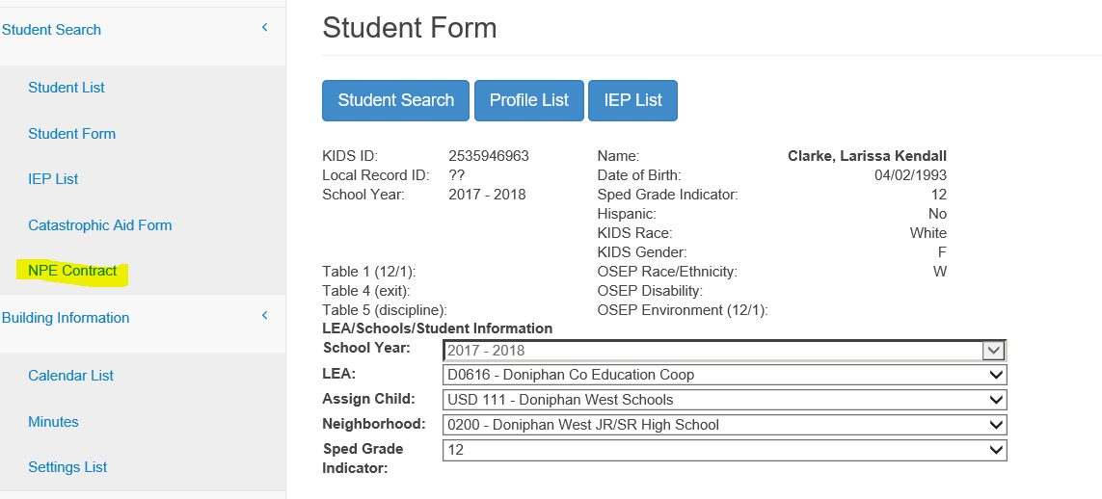

A NPE form can be created by clicking the new button to start a blank form

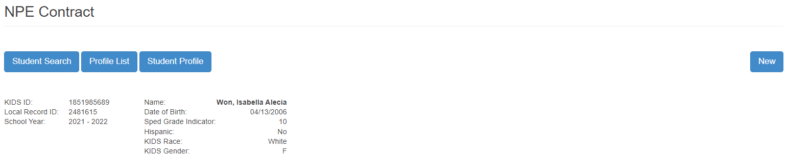

Enter the Payment LEA, contracted agency, provider & license code, service code

Enter the hours of service for the school year and the service start and end dates

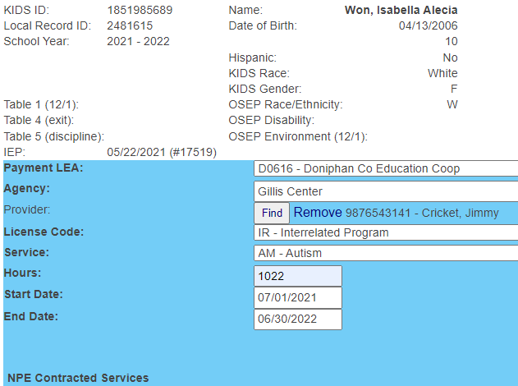



Calculating NPE reimbursement

Step 1 - run the NPE Contract Student level report

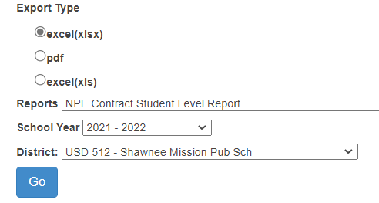

Step 2 - Filter the report by individual student

Step 3 - Sum the student's total FTE for all services

Step 4 - Multiply the total FTE by the current per teacher (categorical aid) entitlement

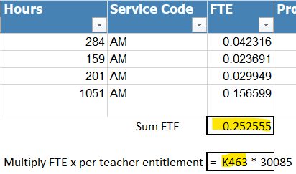

The resulting dollar amount can be reported on the catastrophic aid application on line D2 or D6

# Part XII: Catastrophic Aid

The navigation link in the left pane allows you to access the **Catastrophic Aid List**. A list of existing submissions is displayed. You will note that the submission Status varies depending on where the submission is in the process. The status list may display one of the following: In Progress, Submitted, Reviewed, Approved, or Declined. The Action you will be able to take depends on the Status of the submission.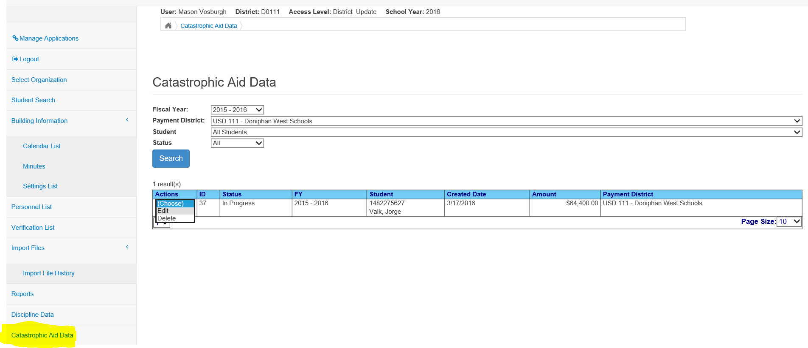

This same screen may also be accessed by clicking on Catastrophic Aid from a student Profile screen. Either way you access the screen, your options will be the same.

New Catastrophic Aid – Accessing the form

A new Catastrophic Aid application is created by completing the application form and submitting the form to KSDE. Accessing the form can be done 2 ways. First do a student search and find and select the student who qualifies for Catastrophic Aid.

1. From the Student List page, choose action “Cat Aid” to navigate to the Catastrophic Aid form.
2. From the student’s IEP List page, click the Catastrophic Aid button to navigate to the Catastrophic Aid form.

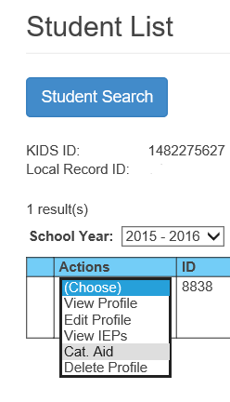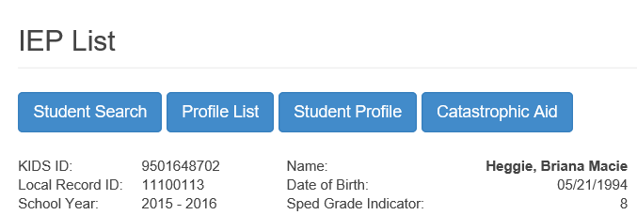

A blank form is displayed.

Fill in the form completing each section, the justifications and expenditures and deductions.

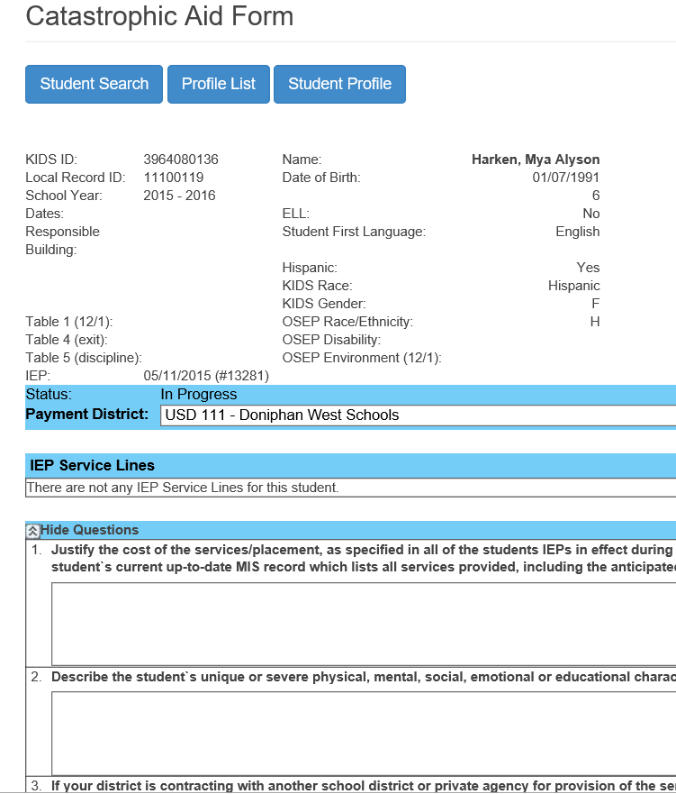

When you have completed the form, you have several options available. **Save** will allow further editing before submitting for approval. **Save & Submit** will send the form on for approval. You will not be able to make changes once you click on this button. **Cancel** will clear the contents of the form and return the form as blank.

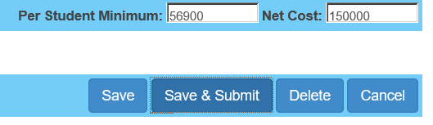

A submission that is still “In Progress” will have the options to Edit, Submit, or Delete.

Edit Catastrophic Aid

From the Catastrophic Aid Data screen, link found on the Navigation Pane on the left. 

Click on the down-arrow on the student you wish to edit. (Remember you are only able to edit a submission that is *In Progress*.) The complete Catastrophic Aid form is now displayed allowing you to enter the information. The form does have several different sections. The various sections are displayed below.



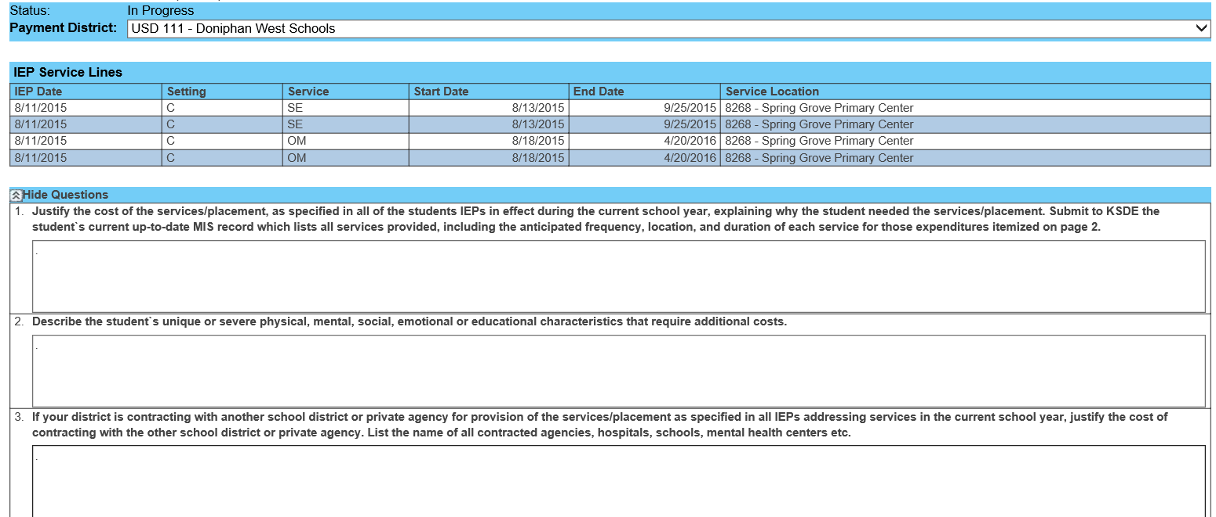Payment District and Justification Questions

Three Justification Questions

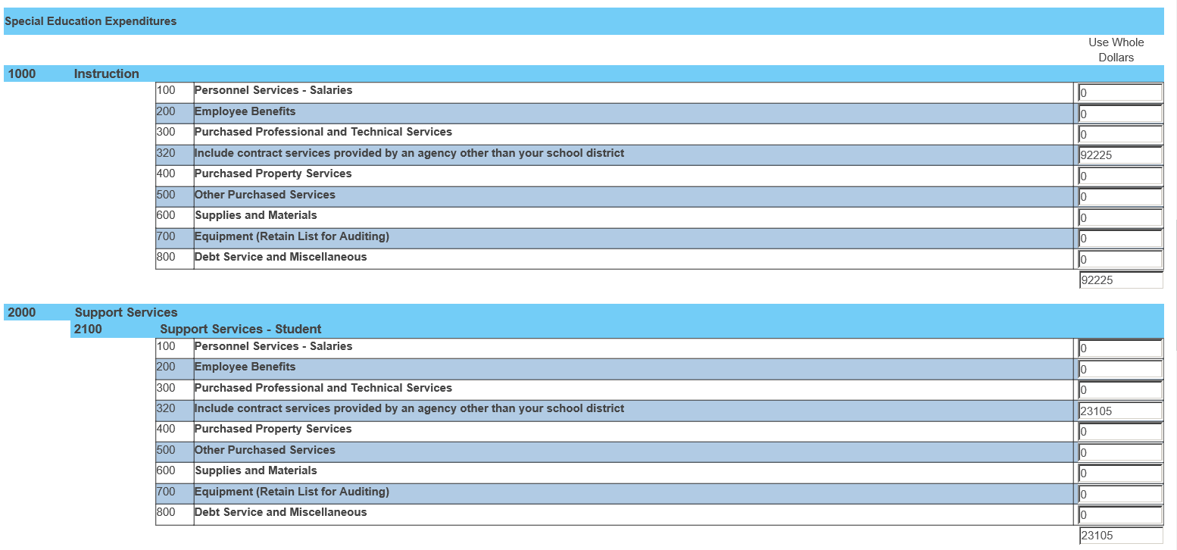

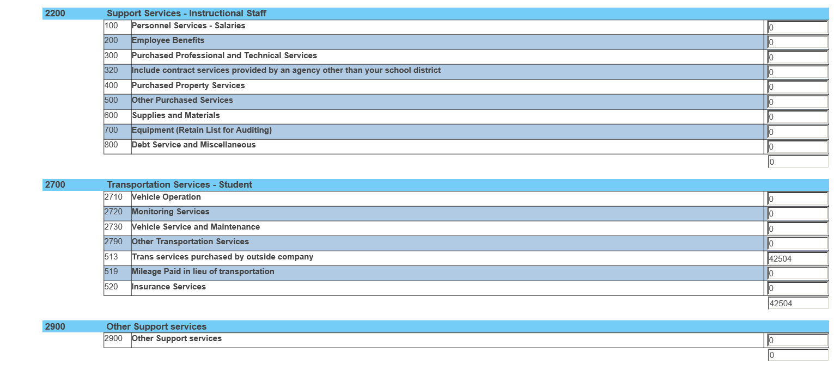

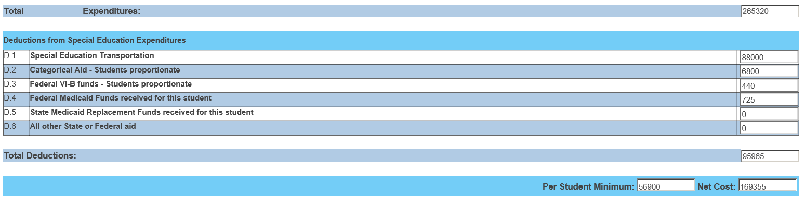

When you have completed the form, you have several options available. **Save** will allow further editing before submitting for approval. **Save & Submit** will send the form on for approval. Once submitted the application is locked for editing. **Delete** will clear this Catastrophic Aid form. **Cancel** will undo any changes made in the form without saving.

Submit Catastrophic Aid

Completed Catastrophic Aid applications can be submitted to KSDE by clicking the Save and Submit button. The form will be automatically submitted for review.

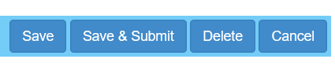

The application process will not be approved if the required sections of the form are incomplete. Including the justifications, expenditures, expense deductions sections. Students must also qualify by meeting the minimum cost threshold. An alert will display if these conditions are not met.

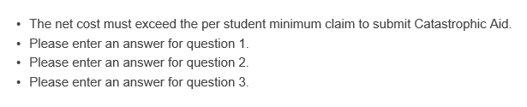

Delete Catastrophic Aid

Using the button or action item delete, all of the justifications, expenditures and deductions will be cleared and a blank form will return.

**Status of Catastrophic Aid applications**



Follow the Catastrophic Aid Data link on the Navigation page. A list of students with catastrophic data entered will be listed by their status

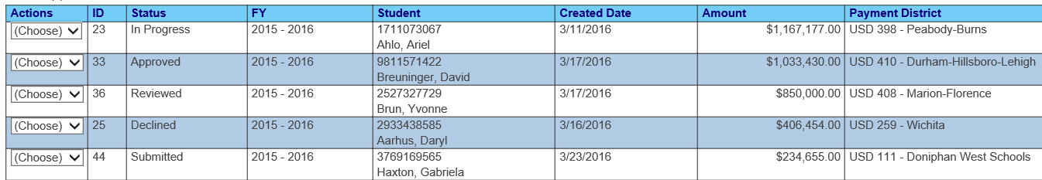

In Progress – Application is open for editing and data entry. Application **Not submitted** to KSDE

Submitted – Application is completed, submitted to KSDE. Application has **not been reviewed**.

Reviewed – Submitted to KSDE, under review. **Approval is pending**

Declined - Application is completed, submitted to KSDE. Approval was declined. Application may be un-submitted, return to “In Progress” status for editing and resubmission.

Approved - Application is completed, submitted to KSDE. Approved, sent to School Finance for payment

# Part XIII: Reports

Reports are accessed on the navigation pane.

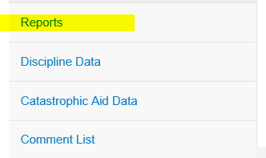

Select the desired report from the drop-down list.

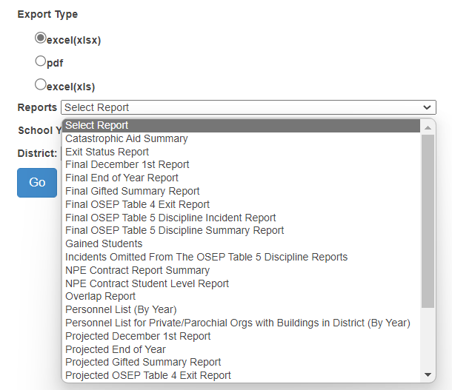

Select the target school year, the organization and export file type. Click the Go button to run the report

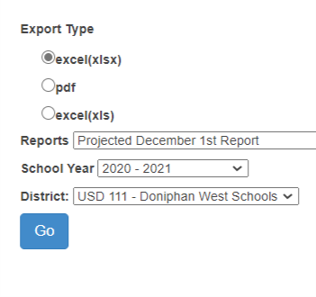

After a report is run, a download prompt is displayed. Download the report in the desired format, either as a PDF file or in Excel format

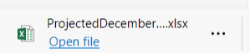

Discipline Data – Projected Incident report.

1. Student with long term out of school Suspension / Expulsion (greater than 11 days) and service line data does not list services in the “U” setting for the same period of time

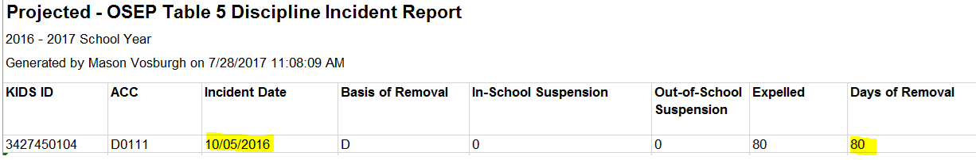

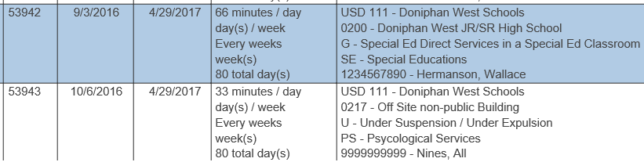

2

1

Service line 1 is in error –

1. Service end date not changed to 10/5/2016. Student was expelled on 10/5/16

Service line 2 is correct –

1. Service start and end dates match date of incident
2. Service location changed to off-site non-public building because student is not allowed on campus. Services are delivered in a community center
3. Service setting changed to “U” because the student is under suspension / expulsion.

**Use filter tools in Excel to find missing or inaccurate values that should not be present.**

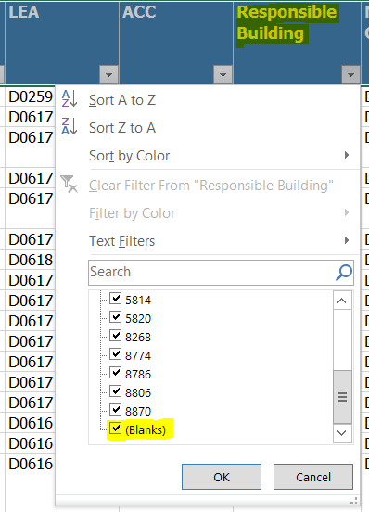

**Responsible building should not have blank or null values.**

Validation Filters

Projected December 1 report – run from beginning of school to February 28.

1. Count and number of students are verified
2. Blank / null values should not be found in the following data fields
   1. Date of Birth, Gender, OSEP race / ethnicity, ELL status, student language
   2. LEA, ACC, Neighborhood & responsible school.
   3. OSEP Environment, OSEP Race / Ethnicity, OSEP Disability
3. X0 and Z0 values should not be present
   1. ACC – Assign Child Count

Projected End of Year report – run from beginning of school to last day of school

1. Count and number of students are verified
2. Blank / null values should not be found in the following data fields
   1. Date of Birth, Gender, OSEP race / ethnicity, ELL status, student language
   2. Grade level, All services, All settings, Most Prevalent Service Location, status codes
   3. LEA, ACC, Neighborhood & responsible school.

3. X0 and Z0 values should not be present in the ACC (assign child count) column

4. June 30 age should not be greater than 21

5. Students with June 30 age of 21 must have an exit date & inactive status by July 1

**Overlap report –** Across service start and end dates

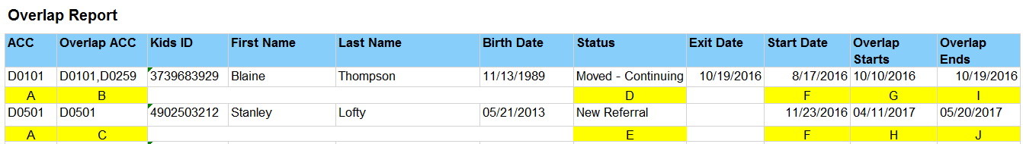

Key indicators to check on overlap reports.

A – Organization of the User is the agency is under the ACC Column. This is your data row.

B – All Overlapping organizations, the User organization and the outside agencies

C – Note: The User organization alone means the overlap is within the IEP services reported by the lone organization. For example; 4/11/17 to 5/20/17 are listed on 2 different IEPs for the student.

D – Status can indicate which organization is causing the overlap. Note: Overlap starts (G) before the student Exit date. This indicates the student entered the new organization before the prior organization exited the student. To correct this example USD 111 changes the exit date and the latest service end date to 10/09/2016

E – Status indicator

F – The earliest start date of service for the student in the ACC organization (A)

G, H – Earliest date of overlapping services.

I, J – Latest end date of overlapping services.

**Verification 0224 reports** -

Report displaying December 1 OSEP categories that have change in the current year data.

Verification 0224 report

Report displays categorical changes between final December 1 value to Current value.

Verification 0224 service line comparison report

Report displays changes frequency, duration, and location between final December 1 value to Current value. These changes show why the OSEP Environment category of currently different.

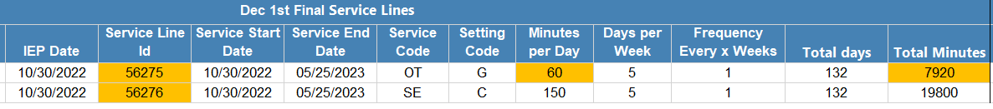

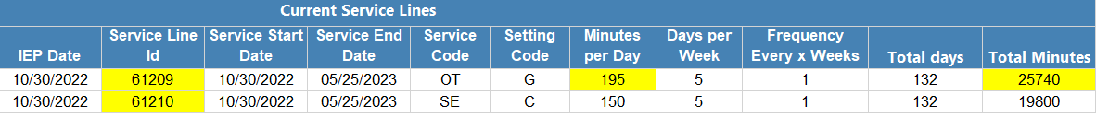

# Part XIV: Discipline Data

Discipline Data is found following the link on the navigation pane. Review the individual incidences. Report any incident that did not happen during the student’s range of IDEA services to the local building administrator for correction. You may also discover other discrepancies such as incorrect basis of removal, incorrect removal types or incorrect number of days of removal. This data will be updated monthly for your review. All discrepant data would be reported back to the building’s data entry person for correction. Check again to see if corrections have been made. If inaccurate data is not corrected, then it will be reported to OSEP and will factor for Indicator 4.

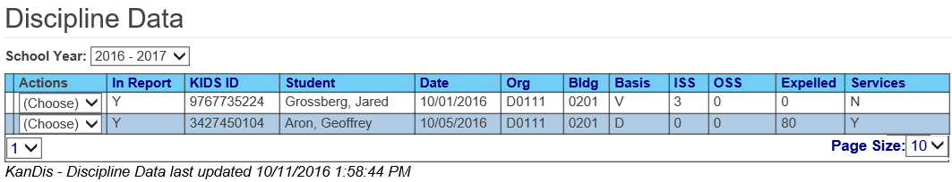

Discipline Cross Check

Look for mis-classification in KIAS as IDEA student or missing IEP services.

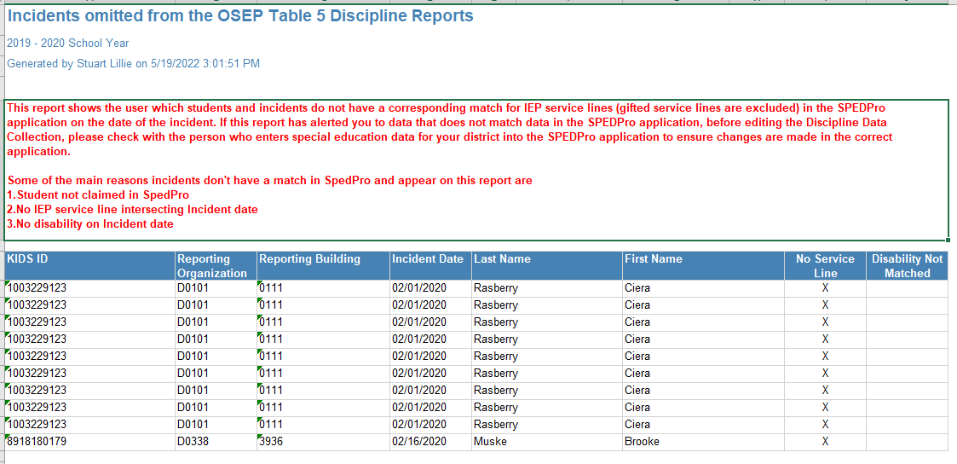

Student reported in KIAS as IDEA, but not found with IEP services on the date of the incident. Notify KIAS user that a correction is needed in the KIAS Discipline record if the student was not IDEA on the date of the incident. Update the SPEDPro record if the student was served on the incident date, thus IEP services need to be added.

**Part XV: Security and Personally Identifiable Information (PII)**

The special education status of students is confidential and may not be divulged to individuals who have no legitimate reason to know. Disclosure of personally, identifiable information (PII) is a violation of the KSDE security policy. Student name and demographics are considered PII. Attaching to or embedding PII in E-mail correspondences to KSDE, is a violation of the KSDE security policy. Infractions of this policy will result in a point deduction from the LEA Timely and Accurate report. Q4 as non-compliant for failing to follow the reporting standards and guidance.

**Security** – In cases when confidential student data needs to be exchanged with KSDE, the Special Education MIS Collection System was developed. This allows for the transmission of record through a secure file wall. The Special Education MIS Collection System is a KSDE web application for which registration and approval to access is required.

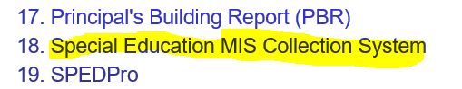

See Part IV: above - Registering for Access to SPEDPro and the Special Education MIS Collection System

To send a file to the MIS Collection system, access the MIS Collection system through the **Common Authentication Login and open the application.**

1. Click the browse button and find the file to be uploaded
2. Select the file
3. Upload the file to the application
4. Notify KSDE that a file is present

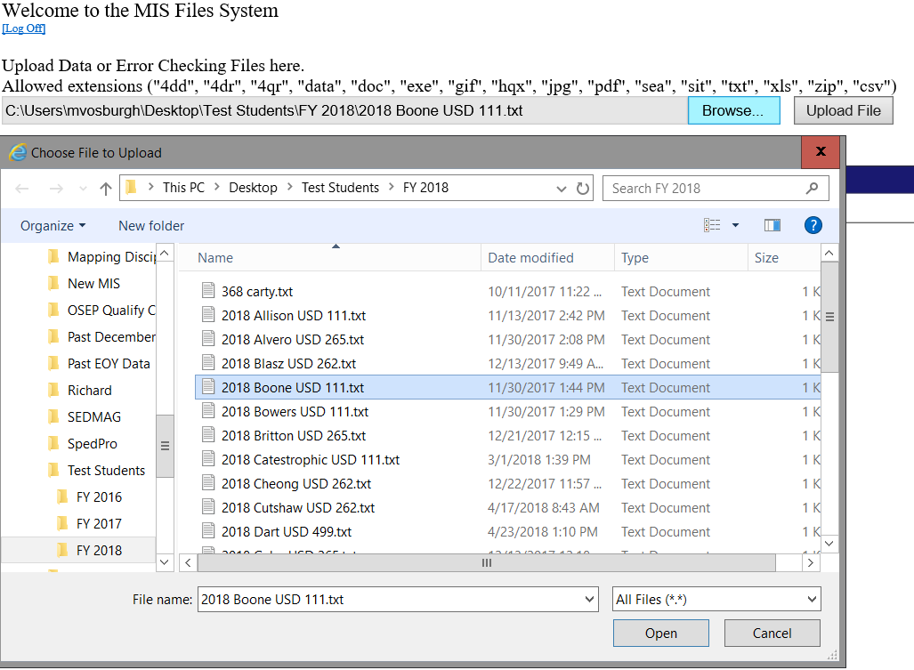

1

3

2

# Part XVI: Help Resources

If you have difficulty working with SPEDPRO, please contact: - SPEDPro Help Desk

**Mason Vosburgh**

**Special Education Data Manager**

Special Education Services

Phone: 785-296-4945

[mvosburgh@ksde.org](mailto:mvosburgh@ksde.org)

**General Guidelines:**

* Focus on the current school year and services delivered during the current school year.
* Rely on KIDS data for student demographics and work closely with your local KIDS coordinator.
* Follow the data dictionary definitions for all data fields.

Support Documents are found at on the MIS and student information page at [www.ksde.org](http://www.ksde.org)

MIS workshops and presentation materials are found at https://ksdetasn.org/gstad

# General Navigation Tips

* Back buttons - Use the back buttons on the SPEDPro application. Avoid using the back buttons on your web browser. SPEDPro cannot load pages completely if the browser back button is used.