PRAYER CERTIFICATION TO KANSAS STATE BOARD OF EDUCATION
Fiscal Year 2024

NOW, on this day of , 2023,
I, , Superintendent of Schools of Unified School District No. , County, State of Kansas, do hereby certify that said Unified School District has no policy that prevents, or otherwise denies participation in, any constitutionally protected prayer in the elementary or secondary schools of said Unified School District. In addition, I do hereby certify that said Unified School District has not had any complaints filed against it in regard to constitutionally protected prayer.
This Certification is made and filed pursuant to 20 USCS β7904.

Signature:
Sign and submit via email by September 15, 2023 to:
Nicole Clark
Special Education & Title Services
Kansas State Department of Education
Landon State Office Building
900 SW Jackson, Suite 620
Topeka, KS 66612
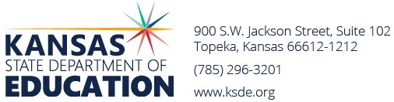
Email: nclark@ksde.org

