April 26, 2019
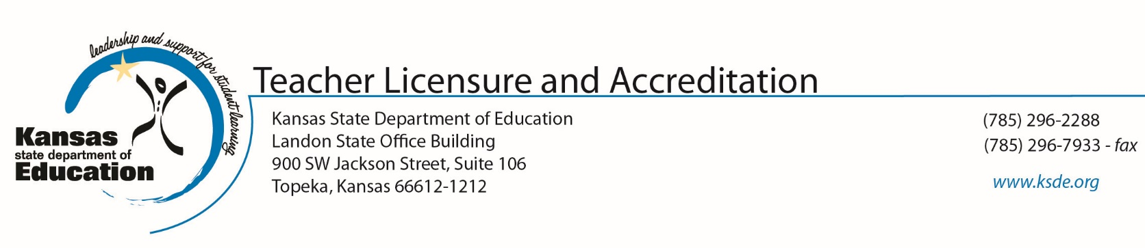
Dear Parent:
The Kansas State Department of Education (KSDE) has contracted with McREL, a non-profit organization, to gather information related to parent perceptions of learning.
Your responses will be used only for statistical purposes. Any data your school/district chooses to provide to KSDE will be district averages. No personally identifiable information about you will be accepted by KSDE.
Your responses will only be viewed by school/district officials as part of the Kansas Education Systems Accreditation (KESA) process. Any data your district chooses to provide to KSDE will be district averages. No personally identifiable information will be accepted by KSDE.
If you have any questions about this survey or your part in it, please contact your school principal. You may also contact KSDE accreditation staff at 785-296-8012 or accreditation@ksde.org.
Respectfully,
Mischel Miller, Ed.S., Director
Teacher Licensure and Accreditation
Jeannette Nobo, Assistant Director
Teacher Licensure and Accreditation

