USD #364 - Marysville

Celebrating 125 years of Bulldog History while preparing for the future
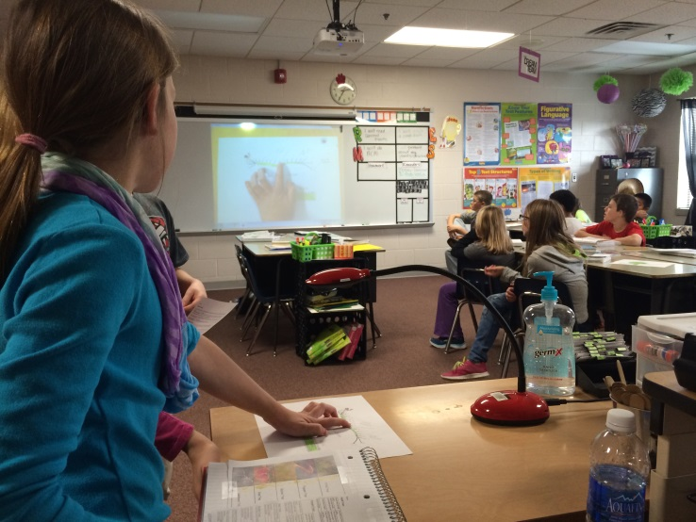
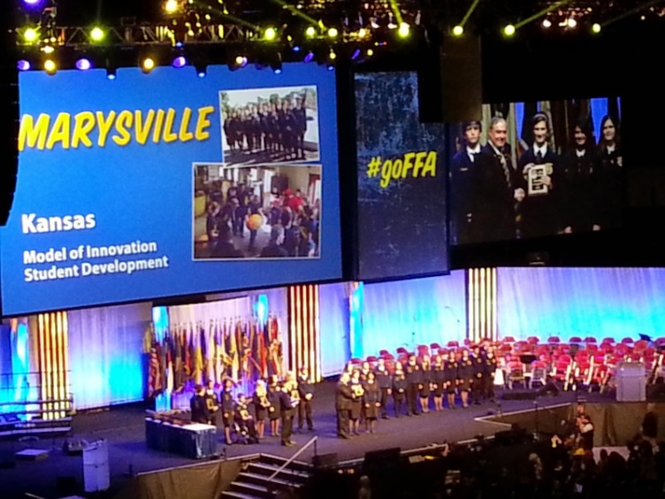

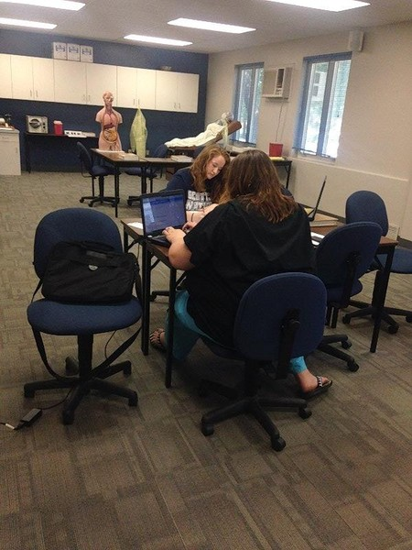

District of Innovation Application
November 24, 2014
Innovative District Application – USD #364
USD #364 in Marysville is in the process of undergoing significant changes in our District. Mr. Bill Mullins began work as our superintendent on July 1, 2014. During his first few months on the job, we have engaged in many meaningful conversations about the vision, mission, and core beliefs of our school district. These conversations are on-going and these statements will likely be revised over the next few months. The current vision statement for the district is “Empowering learners for life-long success”. The most recent mission statement for the district is “Lead by example and expect success”. The current statements that make up our core beliefs are as follows:
- All students can and should experience success
- Effort and engagement lead to continuous improvement
- People – our most valuable asset
- Collaboration leads to learning and growth
- Our curriculum should be challenging, rigorous, and relevant
- Character development is the foundation of our success
As a district, we are committed to building a culture based on Trust, Respect, and Responsibility. We want this culture to extend beyond the school walls and out to our entire community. The Marysville community has always supported the school district and the students by giving generously to help finance specific clubs, organizations, and projects. The Marysville community is a rural farming community located in Marshall County in Northeast Kansas. Marysville is the county seat with a relatively stable population count compared to some of the surrounding communities. The population of the city of Marysville is around 3300 with a student population in the district of around 700 students PK-12. Marysville has a solid economic base with multiple manufacturing plants in town along with a hospital. The city also has a solid Main Street Program to go along with other restaurants and retail establishments in the community.
Introduction
Marysville Public Schools are committed to providing a high quality education for all of the children that we serve. We believe strongly that all children should graduate high school with choices and options for their future. We also believe that students who graduate college and career ready will have more choices and options than those students who do not. Marysville High School currently offers two options for students one being a college-prep curriculum and the other track being a technical option. We are currently working on plans to eliminate these options and adding a College and Career Readiness Requirement as a part of our Graduation Requirements. We currently offer seven Career Pathways at Marysville High School and we would like to expand this program by developing internship programs with local business, community partners, and self-employed individuals in our area. Our students currently have access to four programs through Highland Community College. We hope to provide more access for our students by investigating potential partnerships with other community colleges in our area. We currently offer six different concurrent credit courses through Highland Community College plus additional on-line college courses that students take as an independent study.
As a district, we feel that we have done a good job of preparing our highest performing students for post-secondary success. However, we recognize that we can get better at serving all of our students. Our Board of Education is concerned about our average ACT scores being below the average for the State of Kansas. The teachers in the district share this concern, but we also recognize that we have a higher percentage of students taking the ACT than the overall statewide percentage. As a district, we are lagging behind the State of Kansas as a whole in terms of the percentage of high school graduates enrolled in post-secondary institutions. This trend has been pretty consistent since 2007 with a few exceptions. The percentage of Marysville graduates that are required to take remedial coursework in college has typically been well below the state average since 2007. The passing rates for students who are required to take remedial courses have been mixed with some years being above the state average and other years being below the state average. Math has consistently been the college class that requires the most remediation followed by English and Reading. Marysville has exceeded the state average for two out of the last three years in which data is available for the percentage of students enrolled in post-secondary education who have earned at least one year of college credit. Marysville is also consistently outperforming the state on the percentage of students earning college degrees.
The Board of Education for USD #364 is committed to improving the academic performance of our students in all subject areas on all tests that measure student performance. The Board is specifically interested in boosting the ACT scores of our students because this test is most closely aligned to college admissions and scholarships. The Board has established a goal of implementing a 1:1 initiative by January 2016 with the focus on improving teaching and learning for all students in our district. As a district, we embrace this goal, but we also recognize that putting an electronic device in front of the students does not solve every problem that we face. In fact, it probably increases the number of challenges we will face each day. We do believe that with proper training and support, the increased use of technology in our classrooms will lead to an increase in student achievement.
In preparing the District of Innovation Application for USD #364 – Marysville, we have considered the application of our fellow North Central Kansas League school at Concordia. We seek to have the same exemptions that they requested in their application along with four additional exemptions to be described shortly. The Concordia application references four specific areas some of which may have already been remedied by changes in state regulations. The four areas in Concordia’s application are 1) licensing and recertification challenges, 2) AdvancEd District Accreditation being used instead of the state Accreditation model, 3) the ability to create new pathways as needed to meet the employment needs of their community, and 4) the freedom to award local credit for extra-curricular activities. We would like to learn from Concordia and apply the lessons they have learned to help us improve our district.
USD #364 – Marysville would also like to seek the following exemptions as a District of Innovation. First, we would like to receive an exemption from the requirements to complete evaluations within the first sixty days of each semester for teachers who are in their first three years of teaching or who are in their first year in our district. We feel that the requirements of the McRel Teacher Evaluation System do not align with the timeline requirements that are currently in state law. The second exemption that we would like to pursue would allow our students to receive academic credit for participating in an internship or a mentoring opportunity that is related to a career pathway. We would like to offer our students the same opportunities for pathways that would be available to students living in a metropolitan area such as Wichita, Topeka, or Lawrence. Because of our location and the size of our district, we would need to offer internships and mentoring opportunities to help reach all of our students. In order to receive academic credit for an internship or a mentoring opportunity, the students would have to demonstrate their competency in each of the areas of the Competency Profile Sheet for the course. The third exemption that we would like to pursue may not even require an exemption at all. We would like to add two elements to the Graduation Requirements for Marysville High School beginning with the class of 2019. We would add a College and Career Readiness Requirement for all students. All students would be required to pass a minimum of 2 elective CTE Credits and meet one of the following five criteria 1) Earn at least 18 hours of College Credit, 2) Successfully complete a total of 3 elective CTE Credits from a minimum of four different career pathways, 3) Successfully finish a completer program within a career pathway and earn a certificate based on an end of pathway exam, 4) Earn an Industry Recognized Certificate from an approved program of study, or 5) Successfully complete two years of an approved post-secondary program of study. The second option described above will allow students who are undecided about their futures time to explore and learn more about various career options. The second element that would be added to the Graduation Requirements is a testing component. Graduates of Marysville High School would be required to successfully complete two exams from the following list of five exams in order to qualify for graduation: ACT, ACT WorkKeys, CPASS, ASVAB, or Compass/Asset. This testing requirement will help prepare them for their next steps after high school. As a district, we have made a financial commitment to pay for each of our juniors to take one of these exams.
The final exemption that we are seeking is to be released from the Kansas Assessment Program. As a district, we have made the decision to align ourselves with the ACT Aspire series of assessments. These assessments are aligned to the ACT and they meet all of the requirements of the federal legislation related to testing. This request would be similar to the request that the McPherson School District successfully used to petition the Federal Government and receive a waiver from “No Child Left Behind” testing requirements. In addition to the ACT Aspire, as a district we have started the process of developing performance assessments at each grade level related to writing. We will be developing these further in the coming months so that implementation can begin in 2015-16. There will be three performance assessments related to writing each year for grades 3-10. These performance assessments will cover Narrative Writing, Expository/Informative Writing, and Argument/Persuasive Writing. These assessments will be used to determine if students are learning specific content standards related to Science, Social Studies, and Health.
Sixty Day Requirement
Kansas Statute 72-9003 requires that all teachers in their first and second year of teaching be evaluated twice annually by the 60th day of each semester. This law was originally introduced in 1973 and it has been amended several times over the years. The last revision occurred in 2006. In recent years, the process of teacher evaluations have changed dramatically but this law has not changed to accommodate the increased amount of time and attention that must be devoted to teacher evaluations. USD #364 in Marysville has adopted the McRel Teacher Evaluation System. The amount of time that it takes to complete the McRel Teacher Evaluation System with fidelity is significant. We believe that following the McRel Teacher Evaluation System with fidelity is more important to the long-term success of our teachers and our district than meeting the deadline of the statute. The administrators in our district are in the classrooms observing teaching and learning almost daily doing Classroom Walkthroughs. The administrators are also actively involved in the task of improving teaching and learning everyday. We expect the administrators to be visible and to work towards creating a culture of high expectations and accountability. Our administrators can be more effective by granting us the freedom to vary from the 60 day requirement in the statute.
Another thing to consider related to requiring all teachers in their first two years of employment at our school to have two evaluations completed by the 60th day of each semester is related to the process of not renewing contracts for teachers with this level of experience. We have started discussions about the process that administrators will be required to follow before recommending that a teacher’s contract not be renewed. We take the responsibility of supporting our teachers and helping them improve very seriously. We will have a procedure in place prior to the 2015-16 school year that clearly defines the steps that an administrator must follow to support teachers prior to making the recommendation that their contracts not be renewed. We believe the process that we will put in place will be clearly defined and it will protect teachers from receiving a non-renewal recommendation that is not warranted. I expect that the policy we put in place will provide more support than has been available through the traditional method of requiring evaluations by the 60th day of each semester.
Internships and Mentoring
Conversations in our district have started to change over the past few months relative to the characteristics of an ideal graduate from Marysville High School. We have also been talking about our core beliefs along with the mission and vision of our school district. Recently our conversation has been focused on our graduation requirements and on the courses that we are able to offer at our junior high and high school. During this conversation, we discussed courses we currently offer and our concerns about not having enough course offerings to match the interests of all students. The conversation about our graduation requirements which will be discussed later in this application and the conversations which have been ongoing with members of our community really pushed us to think about how internships and mentoring could benefit our students and our community.
We would like to develop internship and mentoring programs within our community and throughout our county that would allow our students an opportunity to gain specific knowledge, skills, and competencies related to specific Career and Technical Education courses. We would seek to pair our students with qualified individuals, according to KSDE’s new regulations for teaching requirements, in our community and county for internships and mentoring opportunities. We would prefer internships but mentoring programs would allow more students to participate without creating problems related to liability insurance and other related issues for the companies and individuals working with our students. We also believe that internships and mentoring programs make sense for our district because of the student enrollment in our district. As a district, we are unable to employ enough teachers to provide all of the pathways that might be of interest to our students. We believe that we can find enough companies and individuals in the community to provide internships and mentors for all of our students. By focusing on internships and mentors we can provide more opportunities for our students without adding additional staff members. In order to receive any academic credit for an internship or a mentoring program, the student would need to demonstrate that they have met the requirements listed on the Competency Profile Sheet for each internship or mentoring opportunity. We are still having some discussions about who would be eligible to participate in the internships and mentoring programs, but we anticipate these programs would be open to juniors and seniors who are in good standing at the school. We have had some initial conversations with specific business owners and civic groups in the community and the responses have been very favorable.
The rationale behind this request is that we would still be using “teachers” who meet the new criteria published by the state of Kansas to serve as mentors and to supervise the internships. They would provide instruction to individuals or small groups of students either on the high school campus or at another location that is appropriate for the internship or mentoring opportunity. Students would not receive credit for a course unless they had satisfied the requirements for the Competency Profile Sheet for a course.
Graduation Requirements
We are not sure that we need an exemption for this portion of our application, but we feel like this is an important part of our overall plan. We do believe that it is directly related to our desire to implement internship and mentoring programs that connect our students with our community.
We want to do a better job of making sure that our graduates are college and career ready when they receive their high school diplomas. We are proposing to change our graduation requirements to include 4 credits of English and 4 credits of Math for all students. We are also proposing that all students meet a College and Career Readiness Requirement in order to receive a diploma from Marysville High School. These discussions are ongoing as we present this application. The current status of our discussion would allow students to meet the College and Career Readiness Requirement through one of the five different criteria described below:
- Students would earn 2 CTE Elective Credits and earn 18 hours of college credit
- Students would earn a total of 3 CTE Elective Credits from four different Career Pathways recognized by the Kansas Department of Education
- Students would successfully complete a Career Pathway program recognized by the Kansas Department of Education including a CPASS Examination at the end of the coursework
- Students would earn an Industry Recognized Certificate from an approved course of study from Highland Community College or similar program
- Students would successfully complete two years of an approved course of study from Highland Community College or similar program
We believe that by allowing students to choose from these five different options to demonstrate their College and Career Readiness that we can appeal to all students and still allow them the opportunity to participate in other elective programs such as Art, Band, Choir, and Drama.
We also seek to add a testing requirement to our graduation requirements. Again, our goal is to better prepare our students for success beyond high school. We are proposing that all students must successfully take two exams from the following list of five exam options:
- ACT
- ACT WorkKeys
- CPASS
- ASVAB
- Compass/Asset
The term “successfully take” was selected not to require a specific test score but to imply that the test was taken seriously and good effort was demonstrated by the student taking the exam. As a district, we have made a financial commitment to pay for one of these assessments for juniors each year.
We feel that these discussions and pending actions will raise the bar for student expectations in USD #364. Furthermore, we believe that by raising the bar we will produce graduates who are better prepared for success in college and/or a career.
ACT Aspire
We are seeking an exemption from the Kansas Assessment Program with the intention of using the ACT Aspire instead. As a district, we have already made a commitment to purchase the Comprehensive Test Package from ACT. This package includes classroom assessments, interim assessments, and summative assessments for students in grades 3 through 10. We have elected to do this because of the consistency and stability of the ACT testing system. The ACT Aspire summative assessments at the end of each year for students in grades 3 through 10 will include Reading, English, Math, and Science. The classroom assessments and interim assessments will also assess these same subjects. The testing footprint from the ACT Aspire will involve science more than the Kansas Assessment Program and it will also cover more in terms of English. In addition to the ACT Aspire program for students in grades 3 through 10, our district testing plan will require all juniors to take one of the following assessments at no cost to the student:
- ACT
- ACT WorkKeys
- CPASS
- ASVAB
- Compass/Asset

Our district testing program will also include three writing assessments at each grade level. These three writing assessments will cover the following three different genres of writing:
- Narrative
- Informative/Expository
- Persuasive/Argument
These writing assessments will include content from a variety of subjects and will likely include content from History and Government every year.
We are seeking an exemption from the Kansas Assessment Program because our community places a high priority on the ACT Exam. We believe that the Kansas Assessment Program and ACT Aspire intend to prepare students to be college and career ready upon graduation from high school. However, we believe that the ACT Aspire is better aligned with the ACT which is a nationally recognized exam and is backed by years of research and data. As a district, we are concerned about developing an aligned PK-12 curriculum to guide teaching and learning in our district. If we were to try to predict the future of testing in the state of Kansas and across the country we would most likely have trouble making accurate predictions. We feel that the tests our students take later this year will look different in years to come. We are concerned about trying to hit a moving target that has been on the move for the past three or four years. We believe the ACT Aspire Exams and the ACT itself will be largely unchanged in the next five to ten years and we believe that focusing our efforts on a target that is unlikely to move will benefit teaching and learning in our district.
We also seek this exemption because of the success of the McPherson School District in applying and receiving a NCLB waiver from the federal government which allows them to use the ACT Aspire instead of the Kansas Assessment Program. As stated earlier in this narrative, we feel that we can learn valuable lessons from Concordia, McPherson, and the other districts that have earned the distinction of being a District of Innovation. We feel that if the federal government believed in McPherson’s plan for measuring student achievement that we should do everything we can to learn from McPherson and try to give students in Marysville the same opportunities for success.
School and Community Support
One of the board members at Marysville brought the idea of becoming a District of Innovation to our attention last spring. Over the past few months, we have assembled two different councils or committees to consider the option of becoming a District of Innovation along with having discussions about how we as a district can get better. The Superintendent’s Council of Excellence – Staff and the Superintendent’s Council of Excellence – Community have been meeting since September to have these discussions. Our high school principal has engaged the members of our President’s Club in similar discussions about our District Technology Plan and becoming a District of Innovation. We have had tremendous support about all of the ideas that make up our application. At the November 12th Board of Education meeting our board voted 7-0 to support this application to become a District of Innovation. Please find the following examples of what the staff, students, and community have to say about our application and the work that we are doing:
My name is Matt Schmelzle and I reside in Marysville KS. As a parent of 3 children (one who is already in the school system) I feel it is my duty to do what’s best for my children. I have read and reviewed the concepts that Mr. Mullins, the School Board, and the committees have proposed for USD 364. I feel these ideas will enhance the education of our children as they go through school and help prepare them for whatever choice they decide to make after graduating high school. Please consider letting the district adopt these changes so our children can receive the best education they can.
Matt Schmelzle, Parent and Community Member
“Meeting the demands of college and career readiness will require utilization of all school stakeholders (Parents, students, teachers, community members) to ensure student achievement. Providing learning experiences through mentoring programs and internships will increase student knowledge of 21st century skills as well as the ability to achieve success in their college and career endeavors.”
Darren Schroeder - Marysville Jr/Sr High School Principal

As a member of the Marysville community, we are very impressed with Mr. Mullin's enthusiasm and vision for Marysville schools. Having the support of the staff, students, school board and community, we are hopeful this endeavor will fast track forward.
Sue Grauer – Community Member

USD 364 has a long history of being on the forefront of innovative methods. Knowing that we are cutting edge has really given our staff, students, and community a sense of pride and accomplishment. If we are allowed to become a District of Innovation our school community will be further enhanced by the knowledge that we strive to provide excellence for all of our students.
Kathy Totten – Teacher, Marysville Elementary School

“I believe in putting all of our energy in preparing the students for the ACT as it is the test that is most relevant to them. Doing well on the nationally recognized ACT means a student is able to opt out of remedial college classes and qualify for college scholarships. This is motivating for students, parents, and teachers.”
Mickie Crowther - Marysville Jr/Sr High Math teacher

As an educator and a parent I strongly support the idea of becoming a District of Innovation. Please
consider our application to assist our district as we work to move our students to a higher level of learning and living.
Michele Mintzmyer - Marysville Elementary School First Grade Teacher

I believe implementing this program would be very beneficial for everyone. Being a freshman, I don't have many opportunities to study in the field I am interested in which is medicine. By allowing me to have the opportunity to do an internship to count as high school credit, this will allow me to better decide if I see this as a future career.
Having the ACT as our primary test, the teachers can focus and better prepare us for this test. This will give us the opportunity to get a higher score. Getting this higher score, will help us get more scholarships for college. By having these opportunities, it will help me decide my future career. These opportunities will help us make decisions for the future.
Katherine Lauer – Marysville High School Class of 2018

I believe here at Marysville Elementary and USD 364 we would benefit from becoming a District of Innovation. We have new administration at all the buildings and the district office that are dedicated to providing the best educational experience possible.

We feel we are working hard to improve in areas that we need to improve in. We recognize that constant improvement is needed and I think becoming a district of innovation can help us do that.
Jason Wheeler – Principal Marysville Elementary

The development of the “District of Innovation Application” has been a community effort, involving teachers, students, parents and patrons. I feel that Marysville presents a somewhat unique opportunity for the student that is not going to college because of the relative large number of manufacturing companies in the area. Because of my local career experience I can assure the State Board that these local companies are willing to commit time and money to insure that the proposed internship and mentoring programs will succeed. With the additional graduation requirements for college bound students I feel that they will be far better prepared to meet the rigors of higher education.
John C Schmidt – Community Member

As the School Board President I feel that being a District of Innovation will allow us to provide a higher quality education to all students. This will allow them to become well rounded, contributing members of society by experiencing a comprehensive academic program in a safe and nurturing environment conducive to learning. USD 364 has built a strong sense of community by building partnerships between its employees, the students, their families, businesses and other constituencies. Becoming a District of Innovation will allow us to expand and build new partnerships to benefit our students and our community.
Sonya Stohs – USD #364 School Board President

As a school, it is important for us to prepare our students for success. Living in a rural community can present challenges in terms of opportunities for our students. Currently, we are unable to offer courses that may be relevant to the student’s future plan of study or career. As mentioned in the District of Innovation application, it would greatly benefit our students to offer these additional opportunities to our students to better prepare them for their future in being college and career ready. This, among other topics mentioned in the District of Innovation application will support our district in efforts to better serve all of our students.
Mistie Slate – Marysville Junior/Senior High Counselor

Going on 5 years at Marysville Public Schools, I have seen the standard of achievement that USD 364 displays. However, even the best can be made better. I support USD 364’s proposition to become a District of Innovation and its requested exemptions, which I believe can greatly benefit not only our staff, but myself and my peers. For example, as a junior, one of my major concerns is the ACT test. As I am considering my college choices, I have come to realize the importance of the ACT test and would like to see a greater effort to help students such as myself become prepared for this important exam. In addition, I believe an internship/mentoring program is an excellent way for students to make a real-world connection to their future careers. Personally, I am interested in Veterinary Medicine, but few classes currently offered can help me attain skills within this industry. I would love to see a hands-on internship/mentoring program so that students can learn and apply skills outside the traditional classroom setting. Exemptions and programs such as these can help our school district grow and better serve our students and communities. Please consider USD #364 Marysville Public Schools request.
Grace Luebke – Marysville High School Class of 2016

