Curriculum Development Overview
Curriculum Map for Middle School Visual Arts

Content Area | Visual Arts |  | Grade Level | 6th Grade
Course Name/Course Code | Art Foundations
Processes | Grade Level Expectations (GLE) |  |  |  | Performance Standards
- Investigate/plan/make/reflect/refine to Create | - Demonstrate competency in variety of media and available technology for expression of ideas and to understand the creative process. |  |  |  | VA:Cr2.1.6a
 | - Demonstrate appropriate use and environmental implications of the materials, tools, and equipment used in making art. |  |  |  | VA:Cr2.2.6a
 | 3. Plan the creation of a work of art and reflect on and refine works of art over time. |  |  |  | VA:Cr1.1.6a, VA Cr3.1.6a
 | 4. Collaborate effectively to create artwork with personal relevance and a common goal. |  |  |  | VA:Cr1.2.6a
- Select/analyze/share to Present | - Investigate the preservation and presentation of individual works of art and/or collections. |  |  |  | VA:Cr4.1.6a
 | 2. Prepare works of art for an exhibit while conveying meaning and considering the needs of the viewer. |  |  |  | VA:Pr5.1.6a
- Perceive/analyze  /interpret to  Respond | - Reflect and respond to personal artwork through a written artist statement. |  |  |  | VA:Re8.1.6a
 | - Describe, Analyze, Interpret, and Judge artwork to form a personal response to their work and the work of others. |  |  |  | VA:Re9.1.6a
 | - Analyze understanding of the world through examination of art across time and cultures. |  |  |  | VA:Re.7.2.6a, VA:Re.7.2.6a
- Synthesize/relate to Connect | - Investigate how art reflects historical views, current societal concerns, and values/beliefs of a culture. |  |  |  | VA:Cn11.1.6a
 | - Analyze how art is influenced by tradition, time, and place. |  |  |  | VA:Cn10.1.6a
21st Century Skills  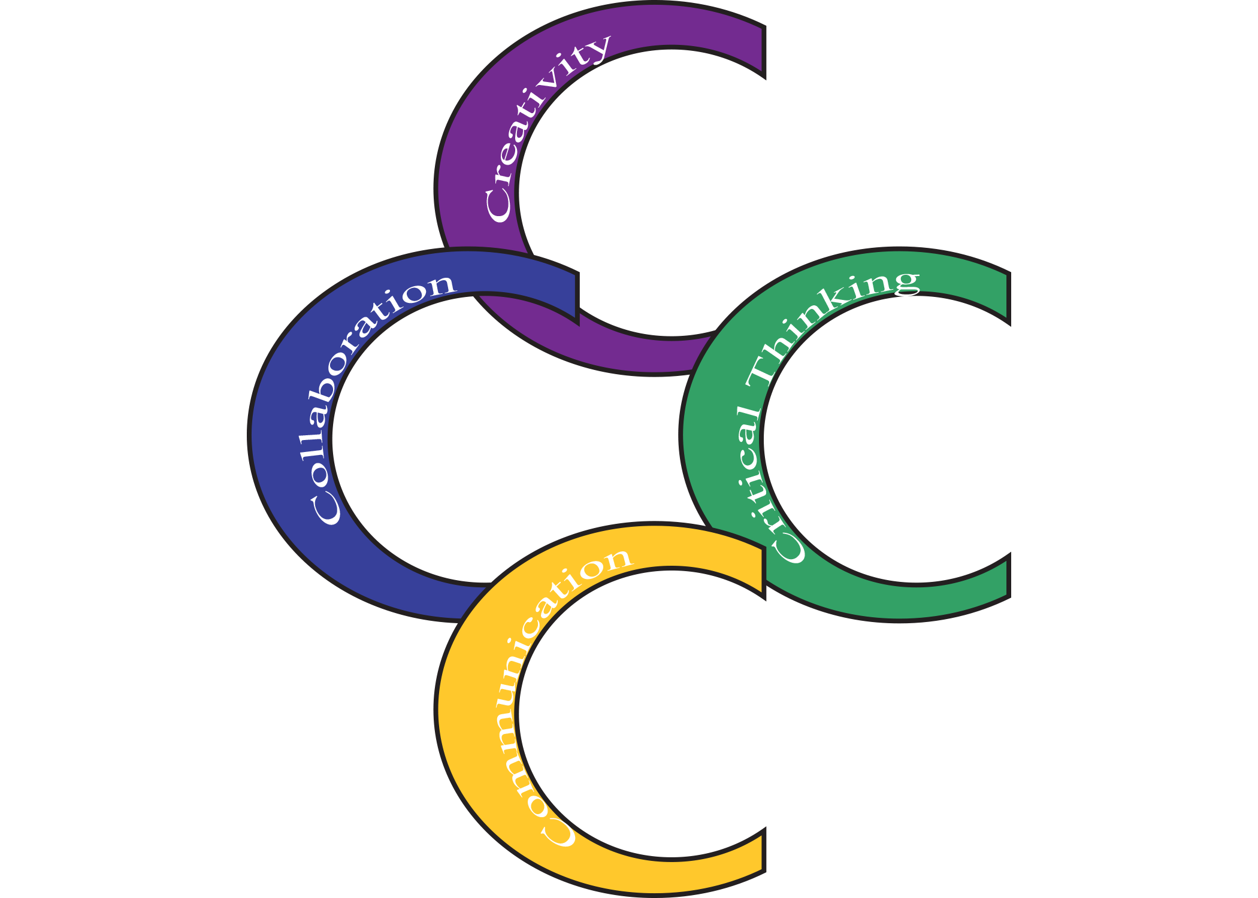  Critical Thinking and Problem Solving: Thinking Deeply & Differently  Creativity: Turning Ideas Into Meaningful Products  Communication: Conveying Ideas  Collaboration: Working & Learning Together |  | 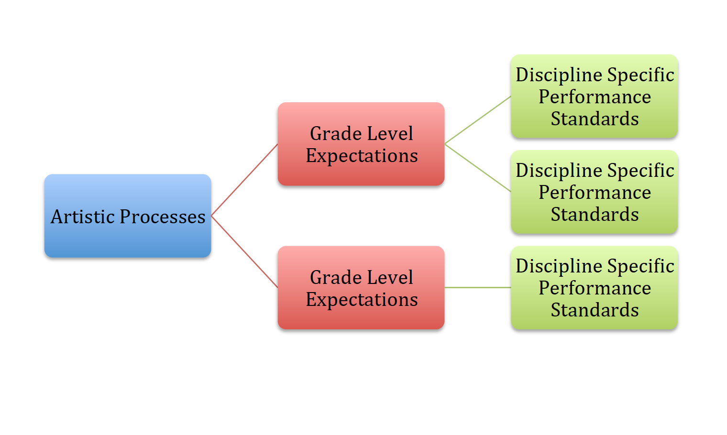  The Augusta USD 402 Visual Arts Curriculum Maps are based on the Kansas Curricular Standards for Visual Arts, and are organized according to the processes of Creating, Presenting, Responding, and Connecting. Lessons and units address the performance standards in a spiral fashion, each building on the previous one in order to increase rigor and relevance. Grade level expectations (GLE) guide lesson design to help ensure students are successful in college, careers, and life by emphasizing 21st Century skills.
Curriculum Development Overview
Unit Planning Sample Template for Middle School Visual Arts

Unit Title | Lesson Title (Example: The Impact of Color) |  |  | Length of Unit | Length of Unit
Focus/Theme | Example: Intention | Performance Standards Addressed in this Unit | Kansas Curricular Standards for Visual Arts Codes  Example: VA:Cn11.1.6a
Questions (specific to unit/lesson): | Examples:  - How do cultures use color to convey meaning in traditional/contemporary rituals, celebrations, and daily lives?  - How can understanding the artist’s inspiration tell us more about the culture and how it’s expressed through color?
Process Components | Examples: Investigate/Plan/Make/Reflect/Refine/Select/Analyze/Share/Perceive/Interpret/Synthesize/Relate
Concepts | Examples: Characteristics and Expressive Features, Culture, Expression / Emotion, Tradition, Style, Investigate, Relationships / Interaction, Inspiration, Tension/Conflict, Intent, Color, Choices

Student Success Criteria  I CAN... | Enduring Understanding Essential Questions  Factual Conceptual
Example: Analyze how art reflects changing times, traditions, resources, and cultural uses. | Example: People develop ideas and understandings of society, culture, and history through their interactions with and analysis of art. | How does art help us to understand the lives of people of different times, places, and cultures?  How is art used to impact the views of society?  How does art preserve the aspects of life?

My students will Know… | My students will be able to Do…
- The foundation of color theory such as; primary, secondary, tertiary, hue, tint, shade, complimentary, contrast, etc.  - How color is used expressively to convey meaning and intent.  - How color has been used by various artists and cultures, historically and culturally (Michelangelo Merisi da Caravaggio: known for chiaroscuro; Vincent Willem van Gogh: known for rough, emotional beauty and impasto; Frida Kahlo de Rivera: Mexican painter, known for her self-portraits; Faith Ringgold: African American artist, known for painting, quilts, storytelling, books.  - Characteristics and expressive features of color (i.e., movement, rhythm, contrast, etc.  - Techniques to complete a painting that demonstrates knowledge of color choice that reflect cultural inspiration. | - Understand and apply the mixing of color.  - Demonstrate a variety of techniques when applying.  - Describe how color choices convey the artist’s intentions.  - Convey a personal understanding of color and style in their artwork.

Critical Language: Includes vocabulary, semantics, and discourse which are particular to and necessary for accessing a given discipline.
EXAMPLE: A student in Language Arts can demonstrate the ability to apply and comprehend critical language through the following statement: “Mark Twain exposes the hypocrisy of slavery through the use of satire.”
A student in ______________ can demonstrate the ability to apply and comprehend critical language through the following statement(s): |  | Through the understanding and use of color, artists can create artwork that conveys culture and style.
Vocabulary: | Primary, secondary, tertiary, hue, tint, shade, complimentary, warm, cool, contrast, rhythm, movement, technique, Culture, Expression/Emotion, Tradition, Style, Investigate, Relationships/Interaction, Inspiration, Intention, Tension/Conflict, Chiaroscuro, Fresco, etc.

Process Component Definitions

Creating
- Investigate- Examine the details of artistic works to discover facts and information.
- Plan- Select and develop artistic ideas for defined purposes and contexts.
- Make- Create works of art to express artistic ideas.
- Reflect- Identify the relationships of artworks to the artist, viewer, and larger audience.
- Refine- Recognize and create ways to improve upon existing artistic works or ideas.

Presenting
- Select- Choose varied works of art to present based on interest, knowledge, skill, and context.
- Analyze- Determine the structure and context of various works of art and their implications for presentation.
- Share- Discover ways to collaborate with others through the use of artistic ideas, processes, and context.

Responding
- Perceive- Understand artistic ideas and purposes.
- Analyze- Determine how the structure and context of various artistic works inform the response.
- Interpret- Support interpretations of artistic works that reflect the artist’s expressive intent.

Connecting
- Synthesize- Combine artistic ideas to produce new meanings.
- Relate- Connect artistic ideas and processes to artist intent and context.

